

Solution Design Document

Oracle Recruiting

**1 DOCUMENT CONTROL**

* 1. Change Record

|  |  |  |  |
| --- | --- | --- | --- |
| Date | Author | Version | Change Reference |
|  |  |  |  |
|  |  |  |  |
|  |  |  |  |
|  |  |  |  |

* 1. Reviewers

|  |  |
| --- | --- |
| Name | Position |
|  |  |
|  |  |
|  |  |

* 1. Approvers

|  |  |
| --- | --- |
| Name | Position |
|  |  |
|  |  |
|  |  |
|  |  |

Contents

1.1 Change Record ii

1.2 Reviewers ii

1.3 Approvers ii

1 Introduction 5

1.1 Purpose 5

1.2 How this document is Organized 6

1.3 Process Symbols 6

2 Standard Business Processes and Mapping in Fusion Recruiting 8

2.1 RECRUITING PROCESS: 8

3 Standard Business Highlights 10

3.1 Creation of Requisition: CCAD_MH_ORC_JR 10

3.2 Candidate Application: CCAD_MH_ORC_CA 22

3.3 Manage Candidate Application 35

3.4 Move To HR 49

4 Pre-Boarding and Onboarding Process: MH_ORC_PB/OB 50

4.1 Pre-boarding Process: MH_ORC_PB 50

4.2 On-boarding Process: MH_ORC_OB 56

4.3 Pre-boarding Process: CCAD_ORC_PB 58

4.4 On-boarding Process: CCAD_ORC_OB 64

5 Recruiting Integration Points 67

6 MS Calendar 69

7 Agent and Agencies 70

8 Notifications and Alerts 71

9 Access and Approval Matrix 73

9.1 Access Matrix 73

9.2 Approval Matrix 74

10 List of Reports 75

11 Career Branding and Vanity Email 76

11.1 Career Branding Details are provided by MH and CCAD 76

11.2 Vanity Email 76

12 Fit Gap Analysis Points 77

13 Open and Closed Issues 78

13.1 Open Issues 78

13.2 Closed Issues 79

14 Sign Off Sheet 80

1. To update the table of contents, put the cursor anywhere in the table and press [F9]. To change the number of levels displayed, select the menu option Insert‑>Index and Tables, make sure the Table of Contents tab is active, and change the Number of Levels to a new value.

# Introduction

The recruitment process includes working with requisitions and tracking applicant information. You enter a requisition to begin the process of filling a vacancy within the organization. A requisition is a record or document that contains information about the open position (an employee assignment for a fiscal year) and job description (the duties that an employee performs for the organization).

This document provides customer with Requisition Management, Candidate Management, Offer Process, and other requirements along with Fit gap analysis section.

1. List the milestones at which the metrics contained below will be recaptured.

## Purpose

1. Document requirements that differentiate the organization from the competition.

The purpose of this document is to describe the key business structural elements that affect subsequent set up of the application. This deliverable is used to assist in the development of application setup. It includes:

* Requisition Process
* Candidate Management
* Offer Process
* Fit Gap Analysis and status
* Open and Closed Points

Recruiters and hiring managers use the Hiring work area to hire new employees and for internal mobility. The Hiring work area includes the following process flows:

## How this document is Organized

This document contains processes which are currently handled by organization.

* The process listing and process description table provides a name and description for each process within the function. The table has the following columns:
  + **Process ID:** An ID to denote each process.
  + **Process Title in Diagram:** Short description of the process in diagram.
  + **Description of the Process:** Detailed description of the process.
  + **Process Type:** Process performed withing system or manual.
* **Open and Closed Issues:** These issues are based on the Gap analysis and customization discussion:
  + Any issue which cannot be mapped with out of box functionality has been included in Open Issues.
  + Any issue which can be mapped with out of box functionality has been included in Closed Issues.

## Process Symbols

The following symbols represent different actions/activities in a process flow and it is included to facilitate process communication-

|  |  |
| --- | --- |
|  | This symbol represents a group of steps or activities to perform |
|  |  |
|  | This symbol represents a Decision. Decisions are typically phased as Yes / No Questions |
|  |  |
|  | This symbol represents information input/output such as report or document. This symbol does not always imply hard copy, as some are verbal |
|  |  |
|  | This symbol represents an offset page reference. Indicates a cross reference with another page of the flowchart |
|  |  |
|  | This symbol represents start and end of the process |
|  |  |
|  | This represents the Manual Operations. Manual Operations are all parts of process which are carried outside the Oracle System |

# Standard Business Processes and Mapping in Fusion Recruiting

This section provides the below details as per MH and CCAD recruiting structure:

* Job requisition management
* Candidate management
* Candidate job application management
* Job offer management
* Hiring management
* Fit Gap Analysis and status as discussed in the CRP sessions.
* Open and Closed Points

This document will cover all process flows in detail in the following section. Along with other subjects

of the solution individually.

## RECRUITING PROCESS:

### Process Details

### Process Step Description

|  |  |  |
| --- | --- | --- |
| Steps | Step Name | Process Description |
| 01 | **Requisition Creation** | Requisition Creation is a shared process between Hiring manager and Recruiter, wherein Hiring Manager can create a requisition using Position, Existing Requisition and Template and will save the requisition. The recruiter will receive the Notification to review the details, update and submit the requisition. |
| 02 | **Job Formatting** | In this step the Recruiter can add “Employer Description” and “Recruiting Organization Description” and “Media” links if any |
| 03 | 1. **Posting** | Recruiters can select the Job Boards on which recruiter will post the requisition. Example internal and external job boards, Agencies, or other job board like LinkedIn. |
| 04 | **Candidate Job Application** | 1. In Candidate Job Application Recruiter can create new candidate and submit their Job Application to any requisition.  2. Agency can submit the Candidate against the Invited Requisitions  3. External and Internal candidate can fill the job application and submit the same. |
| 05 | 1. **Candidate selection Process** | Candidate selection process is a process where candidate must go through some Stages in order get hire like Preliminary Screening, Interview stage, Assessment, Offer Stage. Pre-Employment Medical, HR etc. few stages can be skipped as all stages are not mandatory. |
| 06 | **Offer process** | In this Process, Offer Letter is generated based on details filled in the Offer Application and will be sent for Approval as per the Approval Matrix Attached. Once Approved the Offer can be extended to the candidate for Acceptance |
| 07 | **Pre-Boarding Process** | Recruiter will move candidate to HR and Pre-Boarding checklist will get triggered and candidate will get converted to pending worker. |
| 08 | **Hire** | Recruiter will Convert the Pending working to Employee. Onboarding checklist will get triggered as soon the candidate is converted as employee |

# Standard Business Highlights

The Standard Processes are described below, followed by the approval cycle according to the discussions held during CRP sessions for MH and CCAD.

## Creation of Requisition: CCAD_MH_ORC_JR

A Requisition is a document that describes all the details required to capture a human resource need in the organization. In ORC the requisition form is a standard form which covers all the aspects of the requisition fields. Along with that the system gives the flexibility to extend the form and add more fields to capture more information if required.

* For MH, HCBP will create the requisition and send for approval, and once approved this will be sent to Recruiters to take it forward for posting. For CCAD, Hiring Managers will create the requisition request using “Recruitment Hire Requisition Form” DOR, and this will be sent to Recruiters to take it forward.
* The recruiter will fill in the remaining details and submit the job requisition for approval for MH. For CCAD, once the Recruitment Hire Requisition Form” is approved, recruiter will fill in the remaining details and submit the job requisition for next stage.
* Approval hierarchy will be followed and once the requisition is fully approved, recruiter will update the interview template, questionnaire and do the job formatting.
* If the requisition is rejected, the recruiter will be able to re-submit the requisition after updating.
* As part of the Solution HCBP will be able to create the requisition for MH and Recruiters will be able to create the requisition for CCAD.

### Requisition creation process

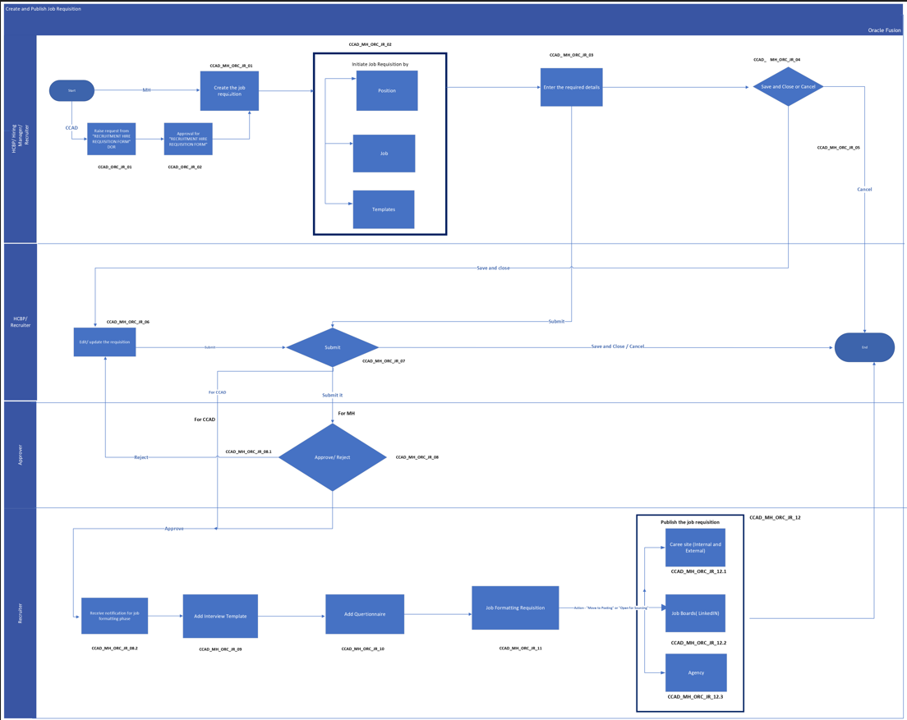

Process Description

The above flow shows a process flow diagram to Create Job requisition in the system. Job Requisition will be created by HCBP/Recruiter/Hiring Manager. In case Job Requisition is already created and need an update only same can be done from the same page by searching the Job requisition to be updated.

* **Process Input**

Information on Job Requisition such as:

* How
* Basic Info
* Requisition Structure
* Hiring Team
* Details
* Work Requirements
* Posting Description
* Offer Info (To be Filled by Recruiter)
* Attachments
* Configuration (To be Filled by Recruiter)
* Questionnaires (To be filled by recruiter)
* **Process Output**
* Upon Approval, Recruiter will be able to Post the new Job Requisition on different Job boards.

Process Step Description

|  |  |  |
| --- | --- | --- |
| **Process Step** | **Process Description** | **Process Type** |
| CCAD_ORC_JR_01 | CCAD Hiring Manager will raise the initial request using DOR “Recruitment Hire Requisition Form” and click on Submit | System |
| CCAD_ORC_JR_02 | Hiring Manager will submit the transaction for approval. Once transaction is submitted, it is routed for approval process as per the approval matrix defined in the system. CCAD Workforce Team will update the recruiter manually once the request is approved as well as Recruitment Team will also receive FYI approval for “Recruitment Hire Requisition Form” | System |
| CCAD_MH_ORC_JR_01 | HCBP will Create new Job Requisition for MH | System |
| CCAD_MH_ORC_JR_02 | To create new Job requisition HCBP will Initiate the Job requisition request by using Job, Template for **MH**   1. **Position**: If HCBP wants to create requisition based on specific position then HCBP can choose position option to copy details of that position and modify the details as per the requirement if needed. If the position you selected has a position requisition template associated with it, you can modify the recruiting-specific fields that are pre-populated by the template. 2. Job: If HCBP wants to create requisition based on specific job then HCBP can choose job option to copy details of that job and modify the details as per the requirement if needed. If the job you selected has a job requisition template associated with it, you can modify the recruiting-specific fields that are pre-populated by the template. 3. Template: This option can be used when HCBP wants to use templates created in the system for Specific position or Specific job or generic template with default values. Template can be created for such requirement and HCBP can use those templates while creating the requisition it will auto fill all the details which is available in template.   To create new Job requisition , Recruiter will Initiate the Job requisition request by using Position, Job, Template for **CCAD**   1. **Position**: If recruiter wants to create requisition based on specific position then recruiter can choose position option to copy details of that position and modify the details as per the requirement if needed. If the position you selected has a position requisition template associated with it, you can modify the recruiting-specific fields that are pre-populated by the template. 2. **Job:** If recruiter wants to create requisition based on specific job then recruiter can choose job option to copy details of that job and modify the details as per the requirement if needed. If the job you selected has a job requisition template associated with it, you can modify the recruiting-specific fields that are pre-populated by the template. 3. Template: This option can be used when recruiter wants to use templates created in the system for Specific position or Specific job or generic template with default values. Template can be created for such requirement and recruiter can use those templates while creating the requisition it will auto fill all the details which is available in template | System |
| CCAD_MH_ORC_JR_03 | Enter the Job Requisition details | System |
| CCAD_MH_ORC_JR_04 | If HCBP or Recruiter selects option “Save and close” the requisition will be saved in draft state. | System |
| CCAD_MH_ORC_JR_05 | If HCBP or Recruiter selects option “Cancel” the requisition will be cancelled. |  |
| CCAD_MH_ORC_JR_06 | If the requisition was saved in draft state, HCBP or Recruiter can edit and update the requisition and finally submit it. | System |
| CCAD_MH_ORC_JR_07 | If HCBP or Recruiter selects option “Submit” the requisition will be moved for approval phase. |  |
| CCAD_MH_ORC_JR_08 | Requisition will be either approved/rejected in the process flow  Approval Matrix will be followed for MH. HCBP will submit the transaction for approval. Once transaction is submitted, it is routed for approval process as per the approval matrix defined in the system.  For CCAD, no approval is required | System |
| CCAD_MH_ORC_JR_08.1 | If Requisition is rejected, then Recruiter will have an option to redraft the Requisition and submit it again. (refer CCAD_MH_ORC_JR_06) |  |
| CCAD_MH_ORC_JR_08.2 | Recruiter will receive the notification once requisition is approved informing recruiter that the requisition is now ready for job formatting state. | System |
| CCAD_MH_ORC_JR_09 | Recruiter can add Interview template for the requisition. | System |
| CCAD_MH_ORC_JR_10 | Recruiter can add/update prescreening questionnaire.  For MH, HCBP will add questionnaire while raising the requisition. | Manual |
| CCAD_MH_ORC_JR_11 | Job Formatting is an optional step and can be skipped by the recruiter. In this step the Recruiter can add “Employer Description” and “Recruiting Organization Description” and “Media” links. | system |
| CCAD_MH_ORC_JR_12 | Recruiter can move to the posting stage by clicking on “Move to Posting” or “Open for sourcing”. | System |
| CCAD_MH_ORC_JR_12.1 | Recruiter can post the requisition to Internal and External Career site. | System |
| CCAD_MH_ORC_JR_12.2 | Recruiter can post the requisition to Job Boards | System |
| CCAD_Mh_ORC_JR_12.3 | Recruiter can assign the requisition to agencies | System |

Requisition Fields

For CCAD, Initial request will start form raising the request via “Recruitment Hire Requisition Form”

|  |  |  |  |  |  |
| --- | --- | --- | --- | --- | --- |
| **Block Name** | **Name of Fields** | **Type of Field** | **Values** | **Mandatory** | **Comment** |
| **How Section** | | | | | |
| Recruitment Hire Requisition Form | Requester Name | Read-Only |  | Yes | Name of the requester |
| Recruitment Hire Requisition Form | Date | Read-Only |  | Yes | Current Date |
| Recruitment Hire Requisition Form | Requestor Position | Read-Only |  | Yes | Position Title of the requestor |
| Recruitment Hire Requisition Form | PBN Number | Text |  |  |  |
| Recruitment Hire Requisition Form | Position Title | Text |  | Yes | Position list will be visible based on persons position hierarchy |
| Recruitment Hire Requisition Form | Function | Text |  | Yes |  |
| Recruitment Hire Requisition Form | Grade | Drop Down |  | Yes | List of active Grades |
| Recruitment Hire Requisition Form | Department | Drop Down |  | Yes | List of active Departments |
| Recruitment Hire Requisition Form | Position Type | Drop Down |  |  |  |
| Recruitment Hire Requisition Form | Reporting To | Text |  |  | Manager Name of the requestor |
| Recruitment Hire Requisition Form | # Caregivers on the ground (same PCN) | Text |  |  |  |
| Recruitment Hire Requisition Form | # Positions already approved for sourcing | Text |  |  |  |
| Recruitment Hire Requisition Form | Vacancy reason | Drop Down | * Contractor (manpower) * Exit * Internal Appointment * New Position |  |  |
| Recruitment Hire Requisition Form | Request for internal or external hire | Drop Down | * Internal * External * Internal and External |  |  |
| Recruitment Hire Requisition Form | Rationale for hiring at this time and any key deliverables expected: | Text |  |  |  |
| Recruitment Hire Requisition Form | Risk Assessment: 6 Months | Text |  |  |  |
| Recruitment Hire Requisition Form | Risk Assessment: 12 Months | Text |  |  |  |
| Recruitment Hire Requisition Form | Attachments |  |  |  |  |

**Requisition Form**: For CCAD, Once the “Recruitment Hire Requisition Form” is submitted and approved, below process will be followed by line manager.

**Process For existing Position** - Line Manager will raise the request from document of record for the existing and submit for approval to Workforce planning team. Workforce planning will take the request with management as offline. Once approved by the management, workforce planning team will approve the DOR request in the application and will also inform the recruitment team as an offline process

**Process For New Position** - Line Manager will raise the request from document of record for the new position and submit for approval to Workforce planning team. Workforce planning will take the request with management as offline. Once approved by the management, workforce planning team will approve the DOR request in the application and will also inform the recruitment team as an offline process with the new PBN Number so that requisition can be raised against it.

Once recruitment team is informed, below form with the fields will be created by recruiter for CCAD.

In MH, the following requisition form with the fields will be created. The same will be used by HCBP or Hiring Manager and Recruiters to fill in the requisition form.

|  |  |  |  |  |  |
| --- | --- | --- | --- | --- | --- |
| **Block Name** | **Name of Fields** | **Type of Field** | **Values** | **Mandatory** | **Comment** |
| **How Section** | | | | | |
| How | Requisition Type | Drop Down | * Standard * Pipeline | No | Pipeline option will be visible to Recruiter |
| How | Use | Drop Down | * Position * Job * Template | Yes |  |
| How | Business Unit | Drop Down | Business Unit List | Yes | On Selection of Position |
| How | Position | Drop Down | List of all Positions | Yes | Position list will be visible based on persons position hierarchy |
| How | Business Unit | Drop Down | Business Unit List | Yes | On Selection of Job |
| How | Job | Drop Down | List of all jobs | Yes |  |
| How | Recruiting Type | Drop Down | * Professional * Contingent | Yes | On Selection of Template |
| How | Primary Location | Drop Down | Manage Geography Hierarchy Value | Yes | On Selection of Template |
| How | Requisition Template | Drop Down | Template name | Yes | On Selection of Template |
|  |  |  |  |  |  |
| **Basic Information** | | | | | |
| Basic Information | Requisition Title | Pre-filled |  | No | This is the name of the Vacancy if other than Position Name |
| Basic Information | Number of Openings (Limited) | Pre-filled | 1 | Yes | Defaulting this field value to “1” |
| Basic Information | Position | Pre-filled | Position Name | No | Read Only Field |
| **Hiring Team** | | | | | |
| Hiring Team | Hiring Manager | Drop Down | List of all Active Employees | Yes | Person name will be populated here who is raising the Requisition, however this is editable field |
| Hiring Team | Recruiter | Drop Down | List of all Active Employees (select recruiter name as advised in note) | Yes | Based on AOR assigned to the Recruiters Smart List of Values can be displayed with Recruiter Name, however user can search for all employee |
| Hiring Team | Collaborators | Drop Down | List of all Active Employees | No | Hiring manager and Recruiter can select his/her co-owners |
| **Requisition Structure** | | | | | |
| Requisition Structure | Recruiting Type | Drop Down | * Professional * Confidential * Contractor * Executive | Yes | On Selection of Position and Job |
| Requisition Structure | Primary Location | Drop Down | Locations Name | Yes | All listed locations |
| Requisition Structure | Other Locations | Drop Down | Locations Name | No | All listed locations |
| Requisition Structure | Job Family | Drop Down | All Job Family name | Yes | Visible to HM and Recruiter |
| Requisition Structure | Job Function | Drop Down | All Job Function Name | Yes | Visible to HM and Recruiter |
| Requisition Structure | Organization | Drop Down | All Organization name | Yes | Visible to HM and Recruiter |
| **Details** | | | | | |
| Details | Worker Type | Drop Down | * Contingent * Employee | Yes | Visible to HM and Recruiter |
| Details | Job Type | Drop Down | * Internship * Standard * Co-op * Summer | No | Visible to HM and Recruiter |
| Details | Education Level | Drop Down | * Some High School * High School Graduate | No | Visible to HM and Recruiter |
| Details | Management Level | Drop Down | * Director * Advisor * Senior Officer | No | Visible to HM and Recruiter |
| Details | Regular or Temporary | Drop Down | * Regular * Temporary | No | Visible to HM and Recruiter |
| Details | Full Time or Part Time | Drop Down | * Full Time * Part Time | No | Visible to HM and Recruiter |
| Details | Organizational Level | Drop Down | * Associate * Director * Executive * Manager * Professional | No | Visible to HM and Recruiter |
| Details | Position Type | Drop Down | * New Position * Replacement | No | Visible to HM and Recruiter |
| Details | Emiratization | Drop Down | * Expat * UAEN | No | Visible to HM and Recruiter |
| Details | Position Name | Drop Down |  | No | Visible to HM and Recruiter  List of active position |
| Details | Gender Preference | Drop Down | * Male * Female * Both | No | Visible to HM and Recruiter |
| Details | Position FTE | Selection |  | No | Visible to HM and Recruiter |
| Details | Available Headcount | Selection |  | No | Visible to HM and Recruiter |
| Details | Recruitment Hire Form | Dropdown |  | No | Only For CCAD, recruiter will select the suitable DOR request form the list  Visible to HM and Recruiter |
| **Work**  **Requirements** | | | | | |
| Work Requirements | Work Hours | Drop Down | * 8 am to 5 pm * 9 am to 6 pm | No | Visible to HM and Recruiter |
| Work Requirements | Work days | Drop Down | * Monday to Friday * Monday to Saturday * Monday, Wednesday, Friday | No | Visible to HM and Recruiter |
| **Posting Description** | | | | | |
| Posting Description | Internal Posting Description | Custom Box | * Description for Internal Candidates * Responsibilities for Internal Candidates * Qualifications for Internal Candidates | Yes | Visible to HM and Recruiter |
| Posting Description | External Posting Description | Custom Box | * Description for Internal Candidates * Responsibilities for Internal Candidates * Qualifications for Internal Candidates | Yes | Visible to HM and Recruiter |
| **Offer Information (Visible to Recruiter only)** | | | | | |
| Offer Info | Legal Employer | Drop Down | Legal Employers Name | Yes | Information will be defaulted based on Hiring Manager Assignment  Read-only for Hiring Manager only |
| Offer Info | Business Unit | Pre-filled | Business Units Name | Yes |
| Offer Info | Department | Drop Down | List of Departments | Yes |
| Offer Info | Primary Location | Drop Down | All Locations Name | Yes |
| Offer Info | Other Work Location | Drop Down | All Locations Name | No |
| Offer Info | Job | Prefilled |  | No |
| Offer Info | Grade | Prefilled |  | Yes |
| **Please attach the additional attachments** | | | | | |
| Attachments |  | Drag and drop |  | No | Visible to HM and Recruiter |
| **Configuration** | | | | | |
| Configuration | Candidate Selection Process | Drop Down | CSP has been created for MH and CCAD | Yes | CSP will be populated based on Requisition template attached to the position selected in “How” section  Visible to Recruiter only |
| Configuration | External Application Flow | Drop Down | Application flow created for MH and CCAD | Yes | CSP will be populated based on Requisition template attached to the position selected in “How” section  Visible to Recruiter only |
| Configuration | Hot job | Drop Down | * Yes * No | No | Visible to Recruiter only |
| Configuration | Allow Candidates to Apply When Not Posted | Drop Down | * Yes * No | No | Visible to Recruiter only |
| Configuration | Automatically Open Requisition for Sourcing | Drop Down | * Yes * No | No | Visible to Recruiter only |
| Configuration | Automatically Fill Requisition | Drop Down | * Yes * No | No | Visible to Recruiter only |
| **Questionnaire** | | | | | |
| Questionnaire |  | List of Questions | * Pre-screening Questionnaire of External Candidate * Pre-screening Questionnaire of Internal Candidate * Interview Feedback Questionnaire | Yes | Visible to Recruiter only |

### Job Formatting

Once Approved, Recruiter can update the requisition with additional details like employer description, Recruiting organization and Media. This is a non-mandatory task.

|  |  |
| --- | --- |
| Entity | Description |
| Employer Description | Information about the company |
| Recruiting Organization | Information about the Business Unit/Department the role will be in |
| Media | Adding Image or video URL |

Job Formatting content yet to be provided by MH and CCAD.

### Manage job Requisition

Once the job is posted to the career sites, the recruiter will have full control over the postings. The following are the actions which recruiters can do to manage the job posting.

• Fill Job Requisition

• Preview Job Requisition

• Suspend Job Requisition

• Cancel Job Requisition

• Send message to team

## Candidate Application: CCAD_MH_ORC_CA

Candidate application flow is a sequence of pages that must be completed by a candidate when applying for a job or when submitting a profile on a Career Section. A candidate can also be matched to a requisition directly by the owners of the requisition.

### Subscription for Talent Community by candidate

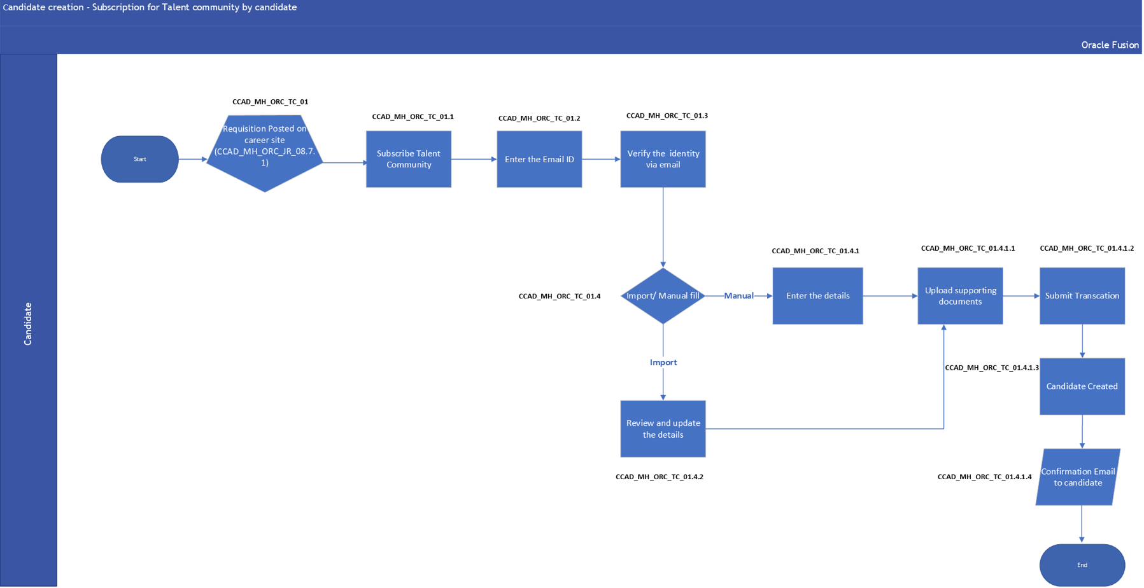

3.2.1.1 Process Description

The above flow shows a process flow diagram of how to subscribe to the talent community when candidate doesn’t find any suitable job.

* **Process Input**

Information to Create Candidate such as:

* Candidate Details
* Document Attachment (If Any)
* **Process Output**
* New Candidate will be created in system.

3.2.1.2 Process Step Description

|  |  |  |
| --- | --- | --- |
| **Process Step** | **Process Description** | **Process Type** |
| **CCAD_MH_ORC_CA_TC_01** | Requisition is posted on career site ref. **CCAD_MH_ORC_JR_08.7.1** | System |
| **CCAD_MH_ORC_CA_TC_01.1** | In case the candidate doesn’t find any job posted matching his profile, candidate can subscribe to Talent Community | System |
| **CCAD_MH_ORC_CA_TC_01.2** | To subscribe to Talent Community candidate will enter the Email Id. | System |
| **CCAD_MH_ORC_CA_TC_01.3** | Email Verification will be done by sending Verification code to candidates email id | System |
| **CCAD_MH_ORC_CA_TC_01.4** | After verification, Candidate will have two options either to fill manual details or import profile from other job boards | Manual |
| **CCAD_MH_ORC_CA_TC_01.4.1** | In case candidate decides to enter the details manually, candidate will enter the details | System |
| **CCAD_MH_ORC_CA_TC_01.4.2** | In case candidate decides to import the data from other Job Boards, candidate can login to other Job portal site and import the profile and candidate can review and update the details | System |
| **CCAD_MH_ORC_CA_TC_01.4.1.1** | Candidate will upload supporting document if required | System |
| **CCAD_MH_ORC_CA_TC_01.4.1.2** | Candidate will submit the transaction | System |
| **CCAD_MH_ORC_CA_TC_01.4.1.3** | Candidate will get created in the Global Talent Community Pool | System |
| **CCAD_MH_ORC_CA_TC_01.4.1.4** | Candidate will receive the confirmation mail | System |

### Candidate Creation – Add Candidate manually by Recruiter/Agency

3.2.2.1 Process Description

The above flow shows a process flow diagram to add candidate manually by Recruiter / Agency.

* **Process Input**

Information to Create Candidate such as:

* Candidate Details
* Document Attachment (If Any)
* **Process Output**
* New Candidate will be created in system.

3.2.2.2 Process Step Description

|  |  |  |
| --- | --- | --- |
| **Process Step** | **Process Description** | **Process Type** |
| **CCAD_MH_ORC_CA_RA_02** | To create new candidate, Initiator can add the candidates in their respective Candidate pools (Here Initiators are Recruiter & Agency) | System |
| **CCAD_MH_ORC_CA_RA_02.2** | Initiator will enter the basic details and can upload the attachments | System |
| **CCAD_MH_ORC_CA_RA_02.3** | Initiator will save and close the page | System |
| **CCAD_MH_ORC_CA_RA_02.4** | Initiator will get confirmation message asking to add more details of candidate or exit the page | Manual |
| **CCAD_MH_ORC_CA_RA_02.5** | In case Initiator decides to continue with the decision, will add more details in the profile. | System |
| **CCAD_MH_ORC_CA_RA_02.6** | In case Initiator decides to continue without addition of any further details, the process gets completed with the basic details provided | System |

### Candidate Application by Employee via Internal Job Portal.

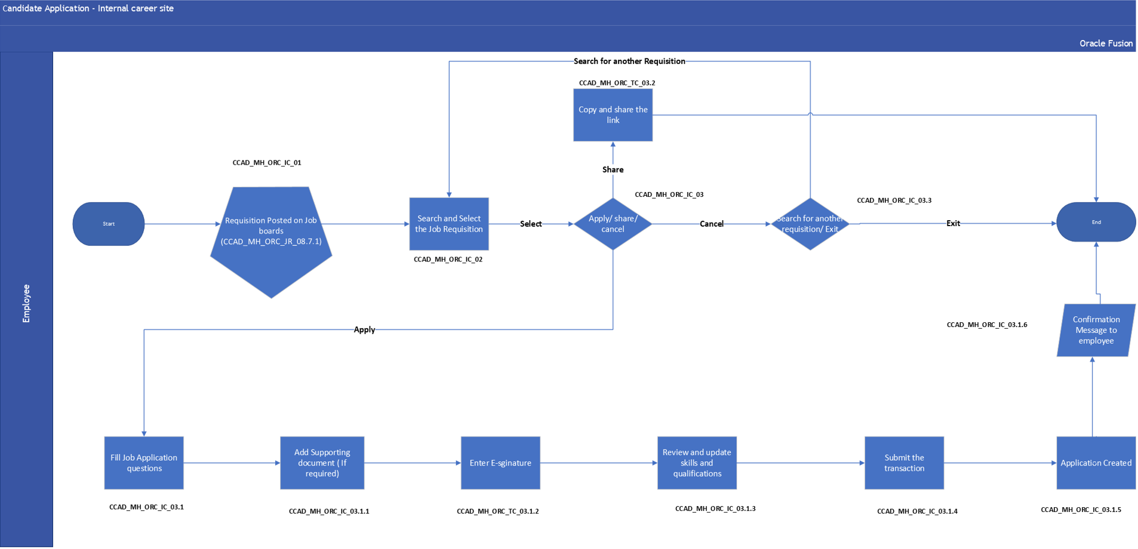

3.2.3.1 Process Description

The above flow shows a process flow diagram to search for the job from internal career portal and submit the job application by Employee.

* **Process Input**

Information for Job Application such as:

* Candidate Personal Information
* Candidate Profile data
* Add Attachment if any
* **Process Output**
* After completion of the process New Job Application will be created into the system

3.2.3.2 Process step Description

|  |  |  |
| --- | --- | --- |
| **Process Step** | **Process Description** | **Process Type** |
| **CCAD_MH_ORC_CA_IC_01** | Requisition is posted on job boards. ref. **CCAD_MH_ORC_JR_08.7.1** | System |
| **CCAD_MH_ORC_CA_IC_02** | Employee will search and select the Job Requisition | System |
| **CCAD_MH_ORC_CA_IC_03** | Employee can either apply for the job or copy and share the link to others or can cancel the entire process. | System |
| **CCAD_MH_ORC_CA_IC_03.1** | If employee applies for the job application, he will fill the job application questions. | System |
| **CCAD_MH_ORC_CA_IC_03.1.1** | Employee will attach supporting documents if required. | System |
| **CCAD_MH_ORC_CA_IC_03.1.2** | Employee will enter full name as E-Signature. | System |
| **CCAD_MH_ORC_CA_IC_03.1.3** | Employee can review and update skills and qualifications. | System |
| **CCAD_MH_ORC_CA_IC_03.1.4** | Employee will submit the transaction. | System |
| **CCAD_MH_ORC_CA_IC_03.1.5** | Once employee submits the transaction, application will be created. |  |
| **CCAD_MH_ORC_CA_IC_03.1.6** | Employee will receive the Confirmation message | System |

### Candidate Application by candidate (External career site)

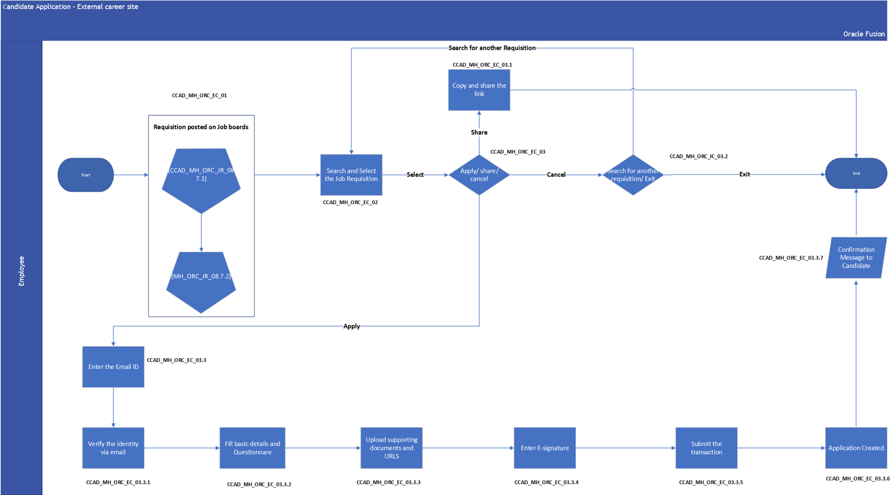

3.2.4.1 Process Description

The above flow shows a process flow diagram to search for the job from external career portal / LinkedIn and submit the job application by Candidate.

Candidate application flow is the forms and list of blocks that the candidate fills while applying for a job. For applying for a job, the candidate follows the following flow.

• If Candidate has already applied for Job Requisition, then he/she can withdraw the application anytime if candidate is no longer interested.

* **Process Input**

Information for Candidate Application such as:

* Candidate Personal Information
* Candidate Profile data
* Add Attachment if any
* **Process Output**
* After completion of the process New Job Application will be created into the system

3.2.4.2 Process step Description

|  |  |  |
| --- | --- | --- |
| **Process Step** | **Process Description** | **Process Type** |
| **CCAD_MH_ORC_CA_EC_01** | Candidate will go to the job boards like LinkedIn, Naukri or External career site to apply for the vacancy. | System |
| **CCAD_MH_ORC_CA_EC_02** | Candidate will search & select the Job Requisition | System |
| **CCAD_MH_ORC_CA_EC_03** | Candidate can Apply the Job requisition or share the same with anyone. | System |
| **CCAD_MH_ORC_CA_EC_03.1** | Candidate can share and copy the link of the job requisition. | Manual |
| **CCAD_MH_ORC_CA_EC_03.2** | Candidate can choose to cancel the entire process by clicking on cancel. | System |
| **CCAD_MH_ORC_CA_EC_03.3** | To Apply for the Job Requisition candidate will enter the Email Id | System |
| **CCAD_MH_ORC_CA_EC_03.3.1** | Email Verification will be done by sending Verification code to email id | System |
| **CCAD_MH_ORC_CA_EC_03.3.2** | After verification Candidate will have to fill all required details and pre-screening questions | System |
| **CCAD_MH_ORC_CA_EC_03.3.3** | Candidate will upload supporting document like CV or miscellaneous document | System |
| **CCAD_MH_ORC_CA_EC_03.3.4** | Candidate will enter the E-signature (Candidates Full name). | System |
| **CCAD_MH_ORC_CA_EC_03.3.5** | Candidate will submit the transaction. | System |
| **CCAD_MH_ORC_CA_EC_03.3.6** | Application will be created once transaction is submitted | System |
| **CCAD_MH_ORC_CA_EC_03.3.7** | Candidate will receive the confirmation mail | System |

### Candidate Application by Recruiter & Agency

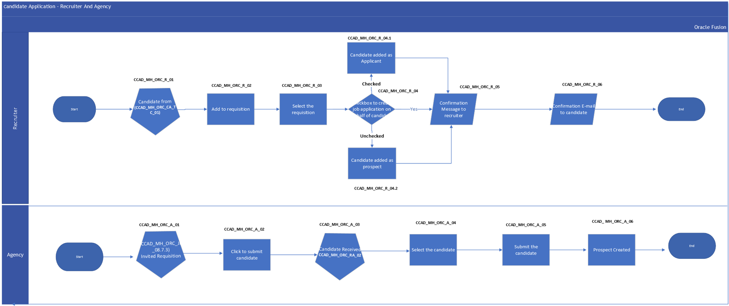

3.2.5.1 Process Description

The above flow shows a process flow diagram convert the candidate to applicant by adding the candidate to Job Requisition by Recruiter/Agency.

1. Recruiter can perform various Actions once candidate is created in system like.
   1. Add to Requisition – Add candidate to new Job requisition.
   2. Add to Candidate Pool – Add a candidate to any Candidate Pool for future reference.
   3. Add Interaction - Recruiter can record all Interaction details.
   4. Send Invite – Send invite to apply for job requisition.
   5. Convert Prospect – Convert Prospect to Job Application
   6. Send Message – send message using Email id.
   7. Update to not interested – Recruiter can update not interested in case candidate doesn’t want to apply for job.
   8. Delete Prospect- Recruiter can delete the candidate.
   9. Check Duplicate – Recruiter can check if the candidate already exists in the system by entering any keyword in the search area.

* **Process Input**

Information for Candidate Application such as:

* Candidate Personal Information
* Candidate Profile data
* Add Attachment if any
* **Process Output**
* After completion of the process New Job Application will be created into the system

3.2.5.2 Process Step description

|  |  |  |
| --- | --- | --- |
| **Process Step** | **Process Description** | **Process Type** |
| **CCAD_MH_ORC_CA_R_01** | Recruiter will select the candidate which is already created in system ref. **CCAD_MH_ORC_CA_TC_01** | System |
| **CCAD_MH_ORC_CA_R_02** | Once Candidate is selected, Recruiter will perform the action, **Add to requisition** | System |
| **CCAD_MH_ORC_CA_R_03** | Recruiter will select the Requisition | System |
| **CCAD_MH_ORC_CA_R_04** | Recruiter will have a checkbox option to create job application on behalf of candidate. | System |
| **CCAD_MH_ORC_CA_R_04.1** | If Recruiter checks the checkbox to create job application on behalf of candidate, candidate will be added as an applicant. | System |
| **CCAD_MH_ORC_CA_R_04.2** | If Recruiter doesn’t check the checkbox to create job application on behalf of candidate, candidate will be added as a prospect. | System |
| **CCAD_MH_ORC_CA_R_05** | Recruiter receives a confirmation message. | System |
| **CCAD_MH_ORC_CA_R_06** | If candidate is added as an applicant, candidate receives a “Provide Additional Info” Email. And if candidate is added as a prospect, candidate receives an Invitation Email. | Manual |
| **CCAD_MH_ORC_CA_A_01** | Agency will receive the Requisition Invitation posted by Recruiter, **ref. CCAD_MH_ORC_JR_08.7.3** | System |
| **CCAD_MH_ORC_CA_A_02** | Agency will Click on Submit Candidate Button to refer the candidate | System |
| **CCAD_MH_ORC_CA_A_03** | Agency will search the candidate created in Talent Pool, ref **CCAD_MH_ORC_CA_RA_02** | System |
| **CCAD_MH_ORC_CA_A_04** | Agency will select the candidate to be referred | System |
| **CCAD_MH_ORC_CA_A_05** | Once Candidate is selected Agency will submit the transaction | System |
| **CCAD_MH_ORC_CA_A_06** | Upon Submission the Prospect get created against the selected requisition | System |

### Candidate Application Flow Requirement Details

The Career site fields will be used when the candidate applies for a particular job. These are the series of fields using which we are asking candidate to provide his/her information (Personal, Educational, Work Experience)

The table below provides a detail about all the fields that would exist on the career section forms for the Career Portals

Candidate information will be captured in the standard form from ORC and the same information will be used for the candidate selection process.

|  |  |  |  |  |  |
| --- | --- | --- | --- | --- | --- |
| **Block Name** | **Name of Fields** | **Type of Field** | **Values** | **Mandatory** | **Comment** |
| Contact information | Last name | Free text |  | Yes |  |
| Contact information | First name | Free text |  | No |  |
| Contact information | Middle name | Free text |  | No |  |
| Contact information | Title | Drop down | 1)      Doctor | No |  |
| 2)      Miss |
| 3)      Mr |
| 4)      Mrs |
| 5)      Ms |
| Contact information | Phone number | Free text |  | No |  |
| Contact information | Email |  |  | Yes |  |
| Contact information | Re-enter Email |  |  | Yes |  |
| Contact information | Nationality | Drop down | List of nationalities in the world | Yes |  |
| Address | Country | Drop down | List of countries defined | No | Please note that the following fields shown will be as per the country selected |
| Address | Emirates | Drop down | List of emirates | Yes |  |
| Address | Address line 1 | Free text |  | No | This should be “current address” |
| Please enter your current address not home address |
| Address | Address line 2 | Free text |  | No |  |
| Address | PO Box | Free text |  | No |  |
| Address | Emirate | Drop Down |  | Yes |  |
| Application questions | List of questions preselected for the requisition | As per configuration of the questions mentioned |  | All questions mandatory |  |
| Experience | Employer Name | Text box |  | Yes |  |
| Experience | Job title | Text Box |  | Yes |  |
| Experience | Start Date | Date | Month  Year | Yes |  |
| Experience | End Date | Date | Month  Year | Yes |  |
| Experience | Current Job | Drop Down | Yes  No | No |  |
| Experience | Employer state and Province | Drop Down | List of State Province | No |  |
| Experience | Employer city | Text |  | No |  |
| Experience | Employer Country | Drop Down | List of countries defined | Yes |  |
| Experience | Reason For Leaving | Text Box |  | Yes |  |
| Experience | Ending Compensation | Decimal |  | Yes |  |
| Experience | Internal | Drop Down | Yes  No | No |  |
| Experience | Job Family | Drop Down | List of Job Family | Yes |  |
| Experience | Job Function | Drop Down | List of Job Function | Yes |  |
| Experience | Ok to Contact Supervisor | Drop Down | Yes  No | No |  |
| Experience | Other Compensation | Text |  | Yes |  |
| Education | City | Text Box |  | No |  |
| Education | Country | Drop Down | List of countries defined | Yes |  |
| Education | Year Acquired | Number |  | Yes |  |
| Education | Duration | Text Box |  | No |  |
| Education | Duration Units | Drop Down | * Day * Months * Year | No |  |
| Education | Education Level | Drop Down | * High School Graduate * Some college * One Year college | No |  |
| Education | School Name | Text |  | No |  |
| Education | Title | Text |  | Yes |  |
| Education | Qualification |  |  | No |  |
| Education | Projected Completion Date | Date |  | No |  |
| Education | Major | Text |  | No |  |
| Education | Minor | Text |  | No |  |
| Education | Highest Education Level | Drop Down |  | Yes |  |
| Education | GPA | Decimal |  | No |  |
| Education | Date Acquired | Date |  | Yes |  |
| Education | Completed Amount | Number |  | No |  |
| Education | Comments |  |  | No |  |
| Education | Area of study | Text |  | Yes |  |
| Education | Average Grade | Text |  | Yes |  |
| Education | Awarding Body | Text |  | Yes |  |
| Education | Description |  |  | Yes |  |
| Licenses and Certificates | License and Certificate | Drop down | * Certified sales Executive * Microsoft certified system Engineer | Yes |  |
| Licenses and Certificates | Certificate Number | Text |  | No |  |
| Licenses and Certificates | Actual Completion Date | Date |  | No |  |
| Licenses and Certificates | Establishment | Drop Down | * Hoseo University * Incheon University | No |  |
| Licenses and Certificates | Original Issue Year | Number |  | Yes |  |
| Licenses and Certificates | Expiration date | Date |  | Yes |  |
| Licenses and Certificates | Certificate Number | Text Box |  | No |  |
| Licenses and Certificates | Issue Date | Date |  | Yes |  |
| Licenses and Certificates | Issued By | Text Box |  | No |  |
| Licenses and Certificates | Last Renewal Date | Date |  | Yes |  |
| Licenses and Certificates | Renewal Required | Drop Down | Yes  No | Yes |  |
| Licenses and Certificates | Country | Drop Down | List of countries | No |  |
| Languages | Language | Drop Down | * Arabic * Arabic (Saudi Arabia) * Bengali | No |  |
| Languages | Native | Drop Down | * Yes * No | No |  |
| Languages | Reading | Drop Down | * High * Moderate * Low | No |  |
| Languages | Speaking | Drop Down | * High * Moderate * Low | No |  |
| Languages | Writing | Drop Down | * High * Moderate * Low | No |  |
| Skills | Skill | Text Box |  | Yes |  |
| Skills | Skill Type | Drop Down | * Adaptation * Communication * Hard Skill | Yes |  |
| Skills | Years of Experience | Number |  | No |  |
| Work Preferences | All Locations |  | Yes  No | Yes |  |
| Work Preferences | Currency Code |  |  | No |  |
| Work Preferences | First Preferred Location | Drop Down |  | No |  |
| Work Preferences | Minimum Pay | Number |  | No |  |
| Work Preferences | Pay Frequency | Drop Down | Yearly  Monthly  Weekly | No |  |
| Work Preferences | Second Preferred Location | Drop Down |  | No |  |
| Work Preferences | Third Preferred Location | Drop Down |  | No |  |
| Attachments |  |  |  | Yes | CV is mandatory to attach |
| E-signature | E-signature | Textbox |  | Yes |  |

## Manage Candidate Application

### 3.3.1 Manage Candidate Selection process by CCAD and MH.

Following is the attached CSP process shared by CCAD and MH.

Following points were agreed in the requirement gathering session.

* There will be only one Candidate Selection Process for both CCAD and MH.
* Few phases of the Candidate Selection Process will be optional, and the recruiter will have access to skip any Phase and Hire the candidate.
* Psychometric Assessment is to be conducted on assessment vendor.
* Offer and Move to HR Phases are Mandatory Steps in all CSP’s.

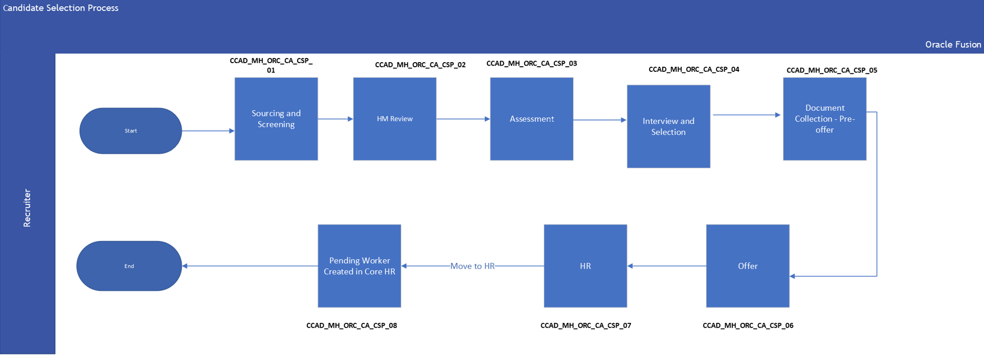

3.3.1.1 Process Description

Candidate Selection Process is the selection process a candidate goes through before being selected. It comprises of phases and within each phase; there are states. Combination of both phase and state will reflect the status of the candidate in the candidate selection workflow (CSP).

3.3.1.2 Process Step Description

|  |  |  |  |  |  |
| --- | --- | --- | --- | --- | --- |
| **Process Step** | **Process Step Name** | **Process Description** | **Process Type** |  |  |
| **CCAD_MH_ORC_CA_CSP_01** | **Sourcing and Screening** | Screening phase will be considered for any new candidate which has applied in the system. Recruiter Screening will be done in this phase. It will be checked if candidate meets minimum requirement. Screening will be initiated by recruiter. Recruiter will share skill assessment form with candidate and do share the response with HM. | System |  |  |
| **CCAD_MH_ORC_CA_CSP_02** | **HM Review** | HM will review the CV for candidates and interested candidates’ status will be updated as “HM Interested in Next Steps” and recruiter will move them to next phase. | System |  |  |
| **CCAD_MH_ORC_CA_CSP_03** | **Assessment** | Recruiter will initiate the assessment for shortlisted candidates at this stage. | System |  |  |
| **CCAD_MH_ORC_CA_CSP_04** | **Interview and selection** | Here interview will be scheduled and after that it will be decided whether to select the candidate for further stage or put the candidate in backup. Interview will generally schedule for 1 hour, out of which half hour is for conducting Test like doing CT -Scan (will be depend on position) and explain it also and the rest time is for interview. | System |  |  |
| **CCAD_MH_ORC_CA_CSP_5** | **Document Collection-Pre -Offer** | Recruiter will ask for the listed documents from the candidate.  1. Passport Copy  2. UAE Residency/Visit visa page  3. Dependents Passport  4. Dependents Emirates ID  5. Salary Certificate/Last 3 months payslip  6. Emirates ID  7. Family Book (UAE National)  And, if any additional information is required, recruiter can also send email communication related to that.  For CCAD, Recruiter will ask for the listed document if not provided by candidate at earlier stage.   1. Emirates ID 2. CCAD CV 3. Passport 4. Employment Application form 5. CCAD Introductory Statement Form 6. Resident Visa 7. Family book for UAE nationals 8. Salary certificate | System |  |  |
| **CCAD_MH_ORC_CA_CSP_6** | **Offer** | Offer is to be created here and drafted. Offer will be approved, accepted, and extended here. | System |  |  |
| **CCAD_MH_ORC_CA_CSP_7** | **HR** | This will be the final stage of the process. After all the above processes the candidate will be moved to HR. | System |  |  |
| **CCAD_MH_ORC_CA_CSP_8** | **Pending Worker** | After Move to HR pending worker will be created in the system. | System |  |  |

### Preescreening and Disqualification Questions for External and Internal Candidate

### Prescreening Questions for External Candidates for CCAD

External Questionnaire list yet to be provided. For now, only sample questions to be used.

|  |  |  |  |  |  |  |
| --- | --- | --- | --- | --- | --- | --- |
| **Sr. No.** | **Question** | **Question Category** | **Answer type** | **Value set (if applicable)** | **Candidate type** | **Comments** |
| 1 | Are you currently working in any of the Entities | Prescreening | Lov (Single Choice) | Yes, No | External | No Need |
| 2 | Do you have relatives working in CCAD or any of the Entities  If yes provide details | Prescreening | Lov (Single Choice) | Yes, No | External | Yes |
| 3 | Have you worked for CCAD in the past?  If yes provide the year | Prescreening | Lov (Single Choice) | Yes, No | External | Yes |
| 4 | How have you heard about us | Prescreening |  |  | External | No Need |
| 5 | Are you eligible to work in UAE? | Prescreening | Lov (Single Choice) | Yes, No | External | No Need |
| 6 | Are you a UAE National?  If yes, do you have a Family Book (Khulasat Al Qaid)? | Prescreening | Lov (Single Choice) | Yes, No | External | Yes |
| 7 | Total years of Clinical Experience | Prescreening | Text |  | External | No Need |
| 8 | Type of Hospital | Prescreening | Text |  | External | No Need |
| 9 | Magnet Accreditation | Prescreening | Text |  | External | No Need |
| 10 | Joint Commission International Accreditation? | Prescreening | Text |  | External | No Need |
| 11 | Bed Capacity within your Unit | Prescreening | Text |  | External | No Need |
| 12 | For Current Job, please mention your Grade/Band | Prescreening | Text |  | External | Yes |
| 13 | Number of Staff Reporting to you (FTEs | Prescreening | Text |  | External | No Need |
| 14 | Has your professional license ever been suspended or revoked? If yes, Please Specify | Prescreening | Lov (Single Choice) | Yes, No | External | Yes |
| 15 | Does the License have any restrictions? If yes, Please specify | Prescreening | Lov (Single Choice) | Yes, No | External | Yes |

### Prescreening and Disqualification Questions for Internal Candidates for CCAD

Internal Questionnaire list yet to be provided. For now, only sample questions to be used.

### Prescreening and Disqualification Questions for External Candidates for MH

Internal Questionnaire list yet to be provided. For now, only sample questions to be used.

|  |  |  |  |  |  |  |
| --- | --- | --- | --- | --- | --- | --- |
| **Sr. No.** | **Question** | **Question Category** | **Answer type** | **Value set (if applicable)** | **Candidate type** | **Comments** |
| 1 | Are you a UAE National? | Prescreening | Lov (Single Choice) | Yes, No | External | No Need |
| 2 | Are you currently licensed to practice in Abu Dhabi? | Prescreening | Lov (Single Choice) | Yes, No | External | No Need |
| 3 | Are you licensed in the UAE by either DOH or MOH or DHA? | Prescreening | Lov (Single Choice) | DOH DHA MOH None of Above | External | No Need |
| 4 | How many dependent children do you have? | Prescreening | Lov (Single Choice) |  | External | No Need |
| 5 | What is your current / most recent salary? (UAE Dirhams) | Prescreening | Text |  | External | No Need |
| 6 | How many years of experience do you have in the healthcare industry? | Prescreening | Lov (Single Choice) | * Less than 1 Year * 1 – 3 Year * 3- 4 Year * More than 4 years | External | No Need |
| 7 | What is your marital status? | Prescreening | Lov (Single Choice) | * Single * Married * Divorce * Widow * Not to be disclosed | External | No Need |
| 8 | What is your notice period in your current job? | Prescreening | Text |  | External | No Need |
| 9 | What level is your highest qualification? | Prescreening | Text |  | External | No Need |
| 10 | Where are you currently located? | Prescreening | Text |  | External | No Need |

### Prescreening and Disqualification Questions for Internal Candidates for MH

Internal Questionnaire list yet to be provided. For now, only sample questions to be used.

### 3.3.3 Manage Interview

3.3.3.1 Process Description

The above flow shows a process flow diagram to schedule an interview with the candidate.

3.3.3.2 Process step Description

|  |  |  |
| --- | --- | --- |
| **Process Step** | **Process Description** | **Process Type** |
| CCAD_MH_ORC_MI_01 | Candidate will be selected at the interview phase in Candidate Selection Process. | System |
| CCAD_MH_ORC_MI_02 | To schedule an interview Recruiter will add the Interview Template for the candidate attached to the Job Requisition. | System |
| CCAD_MH_ORC_MI_03 | Recruiter will enter the Interview details as per the Interview Template | System |
| CCAD_MH_ORC_MI_04 | Recruiter will select the Interviewer and enter the details and save the form | System |
| CCAD_MH_ORC_MI_05 | Notification will be sent to Interviewer and candidate | Manual |

### 3.3.4 Update and Cancel Interview Process

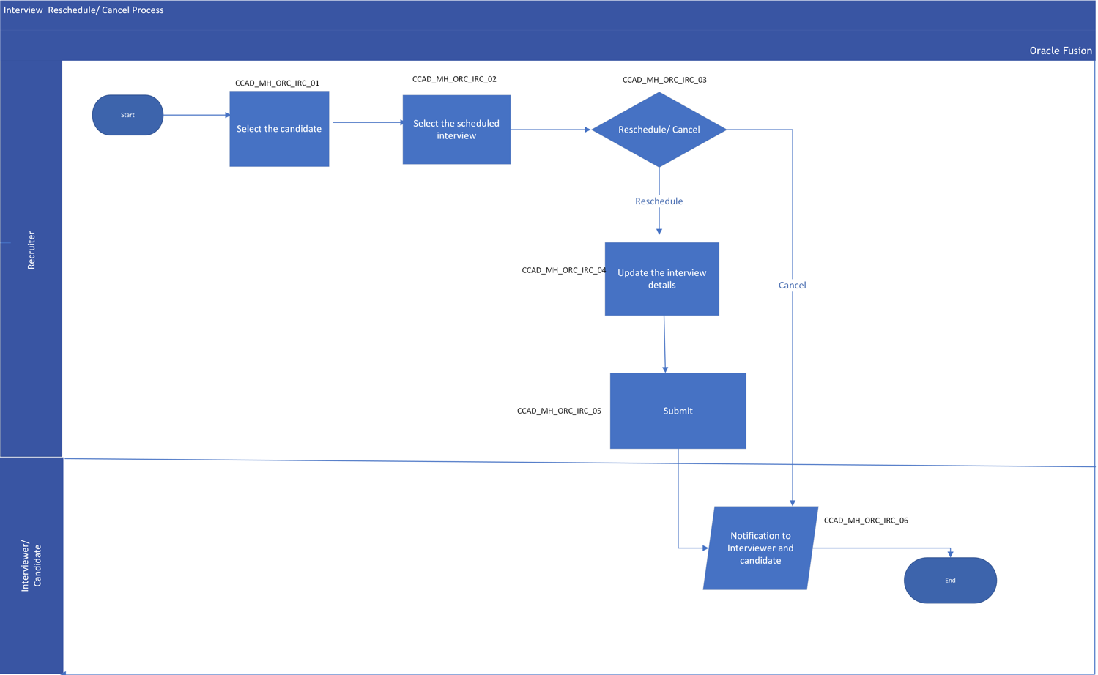

3.3.4.1 Process Description

The above flow shows a process flow diagram to reschedule or cancel an interview with candidate.

* **Process Input**

Information for Manage Interview such as:

* Updated Interview details
* **Process Output**
* Recruiter will reschedule or cancel an interview.

3.3.4.2 Process Step Description

|  |  |  |
| --- | --- | --- |
| **Process Step** | **Process Description** | **Process Type** |
| CCAD_MH_ORC_IRC_01 | Recruiter will select the candidate | System |
| CCAD_MH_ORC_IRC_02 | Recruiter will select the Scheduled Interview | System |
| CCAD_MH_ORC_IRC_03 | Recruiter can either reschedule or cancel the interview. | Manual |
| CCAD_MH_ORC_IRC_04 | Recruiter will update the interview details in case recruiter wants to Reschedule the interview | System |
| CCAD_MH_ORC_IRC_05 | Recruiter will Submit the transaction | System |
| CCAD_MH_ORC_IRC_06 | Notification will be sent to Interviewer and candidate in case of Reschedule or cancelation of Interview. | System |

### 3.3.5 Interview Feedback Form

Below is the attached Interview Feedback form for MH and CCAD.

For CCAD

For MH

### 3.3.6 Manage Job Offer

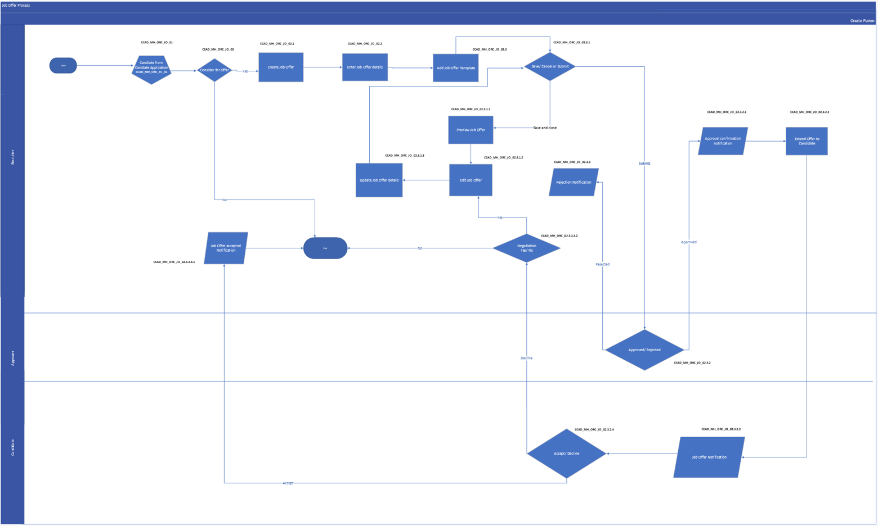

3.3.6.1 Process Description

The above flow shows a process flow diagram to generate Job Offer letter for candidates,

* **Process Input**
* Candidate Job Offer Details
* **Process Output**
* Job Offer Letter will be generated upon the offer accepted by Candidate.

3.3.6.2 Process Step Description

|  |  |  |
| --- | --- | --- |
| **Process Step** | **Process Description** | **Process Type** |
| CCAD_MH_ORC_JO_01 | Recruiter will receive the Application from candidate Application **Ref.- CCAD_MH_ORC_TC_01** | System |
| CCAD_MH_ORC_JO_02 | Recruiter will decide whether to consider candidate for job offer or not | Manual |
| CCAD_MH_ORC_JO_02.1 | In case decision is yes Recruiter will create the Job Offer. | System |
| CCAD_MH_ORC_JO_02.2 | To Create the Job Offer, Recruiter will Create the Job offer by filling the details | System |
| CCAD_MH_ORC_JO_02.3 | Recruiter will select the Job Offer template from the drop-down option | System |
| CCAD_MH_ORC_JO_02.3.1 | After filling all the details Recruiter will decide to Save & Close or submit the offer letter | Manual |
| CCAD_MH_ORC_JO_02.3.1.1 | If recruiter save and closes the job offer, it will be saved as draft, and he can preview the job offer. | Manual |
| CCAD_MH_ORC_JO_02.3.1.2 | Recruiter can edit the job offer by clicking on edit offer option. | System |
| CCAD_MH_ORC_JO_02.3.1.3 | Recruiter will update the job offer details and again continue Ref- **CCAD_MH_ORC_JO_02.3.1** | System |
| CCAD_MH_ORC_JO_02.3.2 | Approver will decide to Approve or Reject the transaction. | Manual |
| CCAD_MH_ORC_JO_02.3.2.1 | In Case if the transaction is approved by all the stake holders, an approval confirmation will be sent to recruiter | System |
| CCAD_MH_ORC_JO_02.3.2.2 | Once the offer is approved, the offer is extended to the candidate by recruiter | System |
| CCAD_MH_ORC_JO_02.3.2.3 | Job Offer notification will be sent to the candidate | System |
| CCAD_MH_ORC_JO_02.3.2.4 | Candidate will decide either to Accept or Reject the job offer | Manual |
| CCAD_MH_ORC_JO_02.3.2.4.1 | In Case of acceptance Recruiter will receive the Job Offer Acceptance notification. And candidate too receive the acknowledgement. | System |
| CCAD_MH_ORC_JO_02.3.3 | If Transaction is rejected by Approver, then notification will be sent to Recruiter for further action. In Case recruiter wants to redraft the job offer please follow steps from **MH_ORC_JO_02.3.1.2** onwards. | System |
| CCAD_MH_ORC_02.3.2.4.2 | If Job Offer is declined by Candidate, then notification will be sent to recruiter for further action, Recruiter can negotiate the job offer, Recruiter will edit job offer by clicking on redraft offer & follow steps from MH**_ORC_JO_02.3.1.2** onwards. If Recruiter declines the negotiation, the process ends. | System |

3.3.6.3 Job Offer Fields

|  |  |  |  |  |
| --- | --- | --- | --- | --- |
| Section | Field Name | Field Type | Mandatory | Values |
| When and why | Estimated Start Date | Date | Y |  |
| When and why | Legal Employer | Drop Down | Y | All list of Legal Entities, the default value will be from Requisition |
| When and why | Action | Drop Down | Y | Add Pending Worker |
| When and why | Worker Type | Drop Down | N | * Employee * Contingent Worker |
| Assignment Info | Assignment status | Drop Down | Y | * Active - Payroll Eligible * Suspended - No Payroll |
| Assignment Info | Business Unit | Drop Down | Y | All list of Business Unit, the default value will be from Requisition |
| Assignment Info | Position | Drop Down | N | All list of Position, the default value will be from Requisition |
| Assignment Info | Job | Defaulted text field | Y | Defaulted from Requisition |
| Assignment Info | Grade | Defaulted text field | Y | Defaulted from Requisition |
| Assignment Info | Department | Drop Down | Y | Defaulted from Requisition |
| Assignment Info | Location | Drop Down | Y | Defaulted from Requisition |
| Assignment Info | Assignment Category | Drop Down | Y | * Allied Health * Non-Clinical – Admin * Non-Clinical - G&A * Nursing * Physician * Research * Resident & Fellows |
| Assignment Info | Regular or Temporary | Drop Down | N | Defaulted from Position   * Regular * Temporary |
| Assignment Info | Full time or Part time | Drop Down | N | Defaulted from Position   * Full Time * Part Time |
| Assignment Info | Working hours | Text box | Y |  |
| Assignment Info | Probation Period | Text Box | N | Value to be entered in case of override |
| Assignment Info | Notice Period | Text box | N | Value to be entered in case of override |
| Assignment Info | Accomodation Required | Drop Down | N |  |
| Assignment Info | Overseas | Drop Down | N | Value to be selected to drive Offer letter clause |
| Assignment Info | Tawtheeq Document | Drop Down | N | Value to be selected to drive Offer letter clause |
| Assignment Info | Source | Drop Down | N | Value to be selected to drive Offer letter clause |
| Assignment Info | Annual Leave Balance Entitlement Override | Text box | N | Value to be selected to drive Offer letter clause |
| Assignment Info | People Group | Text box | N | Value to be selected to drive Offer letter clause |
| Contract Info | Type | Drop Down | N | * Limited * Fixed Term Contract UAE * Fixed Term Contract Expat * ….. |
| Contract Info | Initial Duration | Text box | N | Enter the duration of the contract |
| Contract Info | Contract End Date | Selection | N | End date of the contract. It will be auto- calculated |
| Contract Info | Description | Text box | N |  |
| Contract Info | Employment Status | Drop Down | N | * Family * Bachelor |
| Offer Team | Hiring Manager | Drop Down | N |  |
| Offer Team | Recruiter | Drop Down | N |  |
| Offer Team | Unit HR | Drop Down | N |  |
| Salary | Currency | Drop Down | N |  |
| Salary | Salary Basis | Drop Down | Y | Fields open where you must fill out all salary details. Salary Basis details yet to be discussed with MH and CCAD. |
| Other Compensation | Option | Drop Down | N | Select all the required Allowances applicable for the employee based on different conditions |
| Comments & Attachments | Offer comments | Text box | N |  |
| Comments & Attachments | Internal Documents | Attach file here | N |  |
| Offer Letter | Offer Letter | Drop Down | N |  |
| Offer Letter | Candidate job application language | Prefilled Text box | N |  |
| Offer Letter | Expiration Date | Date | N |  |
| Offer Letter | Additional Text1 | Free text field | N | It can be used in case recruiter would like to add any addition details on Offer Letter |
| Offer Letter | Additional Text2 | Free text field | N | It can be used in case recruiter would like to add any addition details on Offer Letter |

3.3.6.4 Job Offer Letter Templates

Sample Offer letter template were shared by MH and CCAD. Required Offer Letters RTF to be provided by MH and CCAD.

Offer Template shared by MH.

Offer Template shared by CCAD.

## Move To HR

Once the candidate is moved to HR it will be converted as Pending Worker in System and it will be considered as Hired in Oracle Recruitment Cloud. Upon converting Candidate to Pending Worker, Pre-Boarding checklist will be triggered, and task will be assigned to the pending worker as defined in Checklist.

# Pre-Boarding and Onboarding Process: MH_ORC_PB/OB

## Pre-boarding Process: MH_ORC_PB

### 4.1.1 New Hire for MH

A checklist will be triggered based on the Action called Move to HR. Below will be the validation for the tasks to be assigned.

* New Hire- Action is Add Pending Worker
* Re-hire - Action is Add Pending Work Relationship

|  |  |  |  |  |  |  |  |
| --- | --- | --- | --- | --- | --- | --- | --- |
| Sr No. | Checklist Name | Task Name | Mandatory | Performer | Owner | Task Type | Comments |
| 1 | Government Relation | Check Document shared from TA.  1. Passport Copy  2. Emirates ID  3. Residence Visa in the UAE  4.Employment application form  5.CCAD Introductory Statement Form (PDF)  6. CV  7. Clinical CV (PDF) - For only clinical position  8. Signed Offer  9. Family Book Copy (for UAE national)  10. Salary Certificate / Pay Slip (If Available) | Y | Onboarding Team | onboarding Team | Manual | Onboarding Team will check for the required docs from candidates. If docs were not uploaded, candidate will be re-assigned to TA Team for documents. |
| 2 | Government Relation | Request Documents from Candidate:  Personal Photograph | Y | Candidate | Onboarding Team | Manual |  |
| 3 | Government Relation | Attested Education Degree | Y | Candidate | onboarding Team | Manual |  |
| 4 | Government Relation | MH Introductory Form | Y | Candidate | onboarding Team | Manual |  |
| 5 | Government Relation | MH Conflict of Interest Form | Y | Candidate | onboarding Team | Manual |  |
| 6 | Government Relation | MH Declaration of Duplicate Benefits Form | Y | Candidate | onboarding Team | Manual |  |
| 7 | Government Relation | MH Employment Application Form | Y | Candidate | onboarding Team | Manual |  |
| 8 | Government Relation | High School Leaving Certificate | N | Candidate | onboarding Team | Manual |  |
| 9 | Government Relation | Education Qualifications relevant to the PQR position | Y | Candidate | onboarding Team | Manual |  |
| 10 | Government Relation | Education Transcripts | Y | Candidate | onboarding Team | Manual |  |
| 11 | Government Relation | Professional Registration / License to practice | Y | Candidate | onboarding Team | Manual |  |
| 12 | Government Relation | Good Standing Certificate | Y | Candidate | onboarding Team | Manual |  |
| 13 | Government Relation | Other Professional Association/Society Memberships or Certifications | N | Candidate | Onboarding Team | Manual |  |
| 14 | Government Relation | Copy of all Previous & Current Employment Certificates/Letters | N | Candidate | Onboarding Team | Manual |  |
| 15 | Government Relation | Valid Life Support training certificates | Y | Candidate | Onboarding Team | Manual |  |
| 16 | Government Relation | DOH Staff Data Form | Y | Candidate | Onboarding Team | Manual |  |
| 17 | Government Relation | Name Change Official Document | N | Candidate | Onboarding Team | Manual |  |
| 18 | Government Relation | Letter of Authorization for release of information | N | Candidate | Onboarding Team | Manual |  |
| 19 | Government Relation | Dataflow Report | N | Candidate | Onboarding Team | Manual |  |
| 20 | Government Relation | Covid 19 Vaccination Certificate | Y | Candidate | Onboarding Team | Manual |  |
| 21 | Government Relation | Medical Fitness Certificate (Mandatory for UAE National) | Y | Candidate | Onboarding Team | Manual |  |
| 22 | Government Relation | Color Police Clearance Certificate Copy | Y | Candidate | Onboarding Team | Manual |  |
| 23 | Government Relation | Attested marriage certificate (If Applicable) | N | Candidate | Onboarding Team | Manual |  |
| 24 | Government Relation | Attested children birth certificate (If Applicable) | N | Candidate | Onboarding Team | Manual |  |
| 25 | Government Relation | IBAN Letter(From your bank in UAE) | N | Candidate | Onboarding Team | Manual |  |
| 26 | Government Relation | Occupational Health Fitness Certificate | N | Candidate | Onboarding Team | Manual |  |
| 27 | Government Relation | Residency program certificate | Y | Candidate | Onboarding Team | Manual |  |
| 28 | Government Relation | Log book for last 2 years | Y | Candidate | Onboarding Team | Manual |  |
| 29 | Government Relation | Privileges from current facility/clinic/hospital | Y | Candidate | Onboarding Team | Manual |  |
| 30 | Government Relation | Proof of tenancy (Latest) | Y | Candidate | Onboarding Team | Manual |  |
| 31 | Government Relation | Other Documents ( to attach any additional docs) | N | Candidate | Onboarding Team | Manual |  |
| 32 | Government Relation | Tarasul Approval(To be provided by MH TA) (Done outside) | Y | Candidate | Onboarding Team | Manual |  |
| 33 | Government Relation | Process the application | Y | Onboarding Team | Onboarding Team | Manual | 1. Onboarding team will verify the document from “Request Documents from Candidate” task and mark this task as complete manually. It will trigger CID process in next step. |
| 34 | Government Relation | To CID | Y | Onboarding Team | Onboarding Team | Configurable Form | 1. Dependent on task” Process the application”. |
| 35 | Government Relation | To CID – 2nd submission | N | Onboarding Team | Onboarding Team | Configurable Form | 1. Dependent on task” Process the application”. |
| 36 | Government Relation | To Dataflow | Y | Medical Licensing Team | Onboarding Team | Configurable Form | 1. Only for Clinical Roles  2. Dependent on task” Process the application”. |
| 37 | Government Relation | Medical Licensing | Y | Medical Licensing Team | Onboarding Team | Configurable Form | 1. Only for Clinical Roles.  2. Dependent on task” Process the application”. |
| 38 | Government Relation | To update Medical Licensing information into License and certificate | Y | Onboarding Team | Onboarding Team | Application Task | 1. Only for Clinical Roles  2. Dependent on task “ Medical Licensing”. |
| 39 | Mobilization | Set the joining date | Y | Candidate | Onboarding Team | Configurable Form | 1. Dependent on task “WFC approval”. |
| 40 | Mobilization | Confirmed date of joining | Y | Onboarding Team | Onboarding Team | Manual | 1. Dependent on task “Set the joining date”. |
| 41 | Mobilization | Visa details | N | PRO Team | Onboarding Team | Configurable Form | 1. Dependent on task “Confirmed date of joining”. |
| 42 | Mobilization | Travel details (Self) | N | Onboarding Team | Onboarding Team | Configurable Form | 1. Dependent on task “Confirmed date of joining”. |
| 43 | Mobilization | Travel details (Dependent) | N | Onboarding Team | Onboarding Team | Configurable Form | 1. Dependent on task “Travel details (Self)”. |
| 44 | Mobilization | Temporary accommodation requirement | N | Onboarding Team | Onboarding Team | Manual | Onboarding Team will mark this task as complete only if caregiver requires temporary unit |
| 45 | Mobilization | Temporary Accommodation | N | Onboarding Team | Onboarding Team | Configurable Form | 1. Dependent on task “Temporary accommodation requirement”. |
| 46 | Mobilization | Welcome mail to the candidates with joining date | Y | Recruiter | Recruiter | Manual | 1. Dependent on task “Confirmed date of joining”. |
| 47 | Mobilization | Medical Test to be notified to the candidates with the location and other details | Y | Recruiter | Recruiter | Manual | 1. Dependent on task “Confirmed date of joining”. |
| 48 | Mobilization | Visa, Emirates ID and labour card details to be updated in the system | Y | PRO Team | Recruiter |  | 1. Dependent on task “Confirmed date of joining”. |
| 49 | Mobilization | HR inviting employee to join | Y | HR (Asset HR) | Onboarding Team | Manual | 1.Send email to candidate  2.Dependent on task “Confirmed date of joining”. |
| 50 | Mobilization | Line Manager to be informed | Y | Line Manager | Onboarding Team | Manual | 1. Dependent on task “Confirmed date of joining”. |
| 51 | Mobilization | HR conducting orientation(New Caregiver Experience) | Y | HR (Asset HR) | Onboarding Team | Manual | 1. Dependent on task “Confirmed date of joining”. |
| 52 | Mobilization | Request to line manager on the requirements of IT equipment’s | Y | Line Manager | IT Team Asset | Manual | 1. Dependent on task “Confirmed date of joining”. |
| 53 | Mobilization | Request line manager on the seating | Y | Line Manager | Onboarding Team | Manual | 1. Dependent on task “Confirmed date of joining”. |
| 54 | Mobilization | " IT to be notified regarding  1. Laptop  2. Access Card  3. Mail to be created" | Y | IT Team for the Asset | Onboarding Team | Manual | 1. Dependent on task “Confirmed date of joining”. |
| 55 | Mobilization | Preparing Contract | Y | Recruitment Team | Recruitment Team |  | 1. Dependent on task “Confirmed date of joining”.  2. This task is done before the joining date of candidate |
| 56 | Mobilization | Temporary unit Take- over | N | Candidate | Onboarding Team | Manual | 1. Candidate to mark this task as complete when they take over the keys of your temporary unit.  2. Dependent on task “Temporary accommodation requirement”. |

## On-boarding Process: MH_ORC_OB

### 4.2.1 New Hire and Re-Hire for MH

Below will be the validation for the tasks to be assigned.

* Action is Hire for New Hire
* Action is Re-hire an employee for Re-hire.

|  |  |  |  |  |  |  |  |
| --- | --- | --- | --- | --- | --- | --- | --- |
| Sr No. | Checklist Name | Task Name | Mandatory | Performer | Owner | Task Type | Comments |
| 1 | Onboarding | Contract | Y | Onboarding Team | Onboarding Team | Manual | share the contract with the new caregivers for the signature and to return it back |
| 2 | Onboarding | NCE Survey | Y | Employee | Onboarding Team | Questionnaire | Dependent on task “Contract”. |
| 3 | Onboarding | Profile (Personal info) | Y | Employee | Onboarding Team | Application Task | Dependent on task “Contract”. |
| 4 | Onboarding | Dependent details and Documents | Y | Employee | Onboarding Team | Application Task | Dependent on task “Contract”. |
| 5 | Onboarding | Emergency contact | Y | Employee | Onboarding Team | Application Task | Dependent on task “Contract”. |
| 6 | Onboarding | Bank info | Y | Employee | Onboarding Team | Application Task | Dependent on task “Contract”. |
| 7 | Onboarding | Beneficiary contact | Y | Employee | Onboarding Team | Application Task | Dependent on task “Contract”. |
| 8 | Onboarding | Housing | Y | Employee | Onboarding Team | Application Task | Dependent on task “Contract”. |
| 9 | Onboarding | Education Degree/ Equalization | Y | Employee | Onboarding Team | Application Task | Dependent on task “Contract”. |
| 10 | Onboarding | IT Policy | Y | Employee | Onboarding Team | Document | Dependent on task “Contract”. |
| 11 | Onboarding | Email Policy | Y | Employee | Onboarding Team | Document | Dependent on task “Contract”. |
| 12 | Onboarding | Access card policy | Y | Employee | Onboarding Team | Document | Dependent on task “Contract”. |
| 13 | Onboarding | Orientation acknowledgement | Y | Employee | Onboarding Team | Document | Dependent on task “Contract”. |
| 14 | Onboarding | Emirates ID deduction Acknowledgement | Y | Employee | Onboarding Team | Document | Dependent on task “Contract”. |
| 15 | Onboarding | HSE Induction acknowledgement | Y | Employee | Onboarding Team | Document | Dependent on task “Contract”. |
| 16 | Onboarding | HR to inform medical insurance and provide the documents | Y | Employee | Onboarding Team | Manual | Dependent on task “Contract”. |
| 17 | Onboarding | Sharing information about mobile app of XYZ Medical insurance provider | Y | Employee | Onboarding Team | Manual | Dependent on task “Contract”. |
| 18 | Onboarding | Pension enrollment | Y | Employee | Onboarding Team | Manual | 1.Dependent on task “Contract”.  2. Only UAE and GCC national |
| 19 | Onboarding | Life Insurance enrollment | Y | Employee | Onboarding Team | Manual | 1. Dependent on task “Contract”.  2. only for MH corporate |
| 20 | Onboarding | Bio- metric enrollment | Y | Employee | Onboarding Team | Manual | Dependent on task “Contract”. |
| 21 | Onboarding | Declaration Form | Y | Employee | Onboarding Team | Document/ Report | Dependent on task “Contract”. |

## Pre-boarding Process: CCAD_ORC_PB

#### 4.3.1 New Hire and Re-hire for CCAD

A checklist will be triggered based on the Action called Move to HR. Below will be the validation for the tasks to be assigned.

* New Hire- Action is Add Pending Worker
* Re-hire - Action is Add Pending Work Relationship

|  |  |  |  |  |  |  |  |
| --- | --- | --- | --- | --- | --- | --- | --- |
| Sr No. | Checklist Name | Task Name | Mandatory | Performer | Owner | Task Type | Comments |
| 1 | Government Relation | Check Document shared from TA.  1. Passport Copy  2. Emirates ID  3. Residence Visa in the UAE  4.Employment application form  5.CCAD Introductory Statement Form (PDF)  6. CV  7. Clinical CV (PDF) - For only clinical position  8. Signed Offer  9. Family Book Copy (for UAE national)  10. Salary Certificate / Pay Slip (If Available) | Y | Onboarding Team | Warda | Manual | Onboarding Team will check for the required docs from candidates. If docs were not uploaded, candidate will be re-assigned to TA Team for documents. |
| 2 | Government Relation | Assign the candidate to the team | Y | Onboarding Team | Warda | Manual | Someone from the Onboarding Team will re-assign the tasks to |
| 3 | Government Relation | Request Documents from Candidate:  Personal Photograph | Y | Candidate | Warda | Manual |  |
| 4 | Government Relation | CCAD Health History Questionnaires | Y | Candidate | Occupational Team | Manual | To be visible to Occupational Team only |
| 5 | Government Relation | Attested Education Degree | Y | Candidate | Warda | Manual |  |
| 6 | Government Relation | High School Leaving Certificate | N | Candidate | Warda | Manual |  |
| 7 | Government Relation | Education Qualifications relevant to the PQR position | Y | Candidate | Warda | Manual |  |
| 8 | Government Relation | Education Transcripts | Y | Candidate | Warda | Manual |  |
| 9 | Government Relation | Professional Registration / License to practice | Y | Candidate | Warda | Manual |  |
| 10 | Government Relation | Good Standing Certificate | Y | Candidate | Warda | Manual |  |
| 11 | Government Relation | Other Professional Association/Society Memberships or Certifications | N | Candidate | Warda | Manual |  |
| 12 | Government Relation | Copy of all Previous & Current Employment Certificates/Letters | N | Candidate | Warda | Manual |  |
| 13 | Government Relation | Valid Life Support training certificates | Y | Candidate | Warda | Manual |  |
| 14 | Government Relation | DOH Staff Data Form | Y | Candidate | Warda | Manual |  |
| 15 | Government Relation | Name Change Official Document | N | Candidate | Warda | Manual |  |
| 16 | Government Relation | Letter of Authorization for release of information | N | Candidate | Warda | Manual |  |
| 17 | Government Relation | Dataflow Report | N | Candidate | Warda | Manual |  |
| 18 | Government Relation | Covid 19 Vaccination Certificate | Y | Candidate | Warda | Manual |  |
| 19 | Government Relation | Medical Fitness Certificate (Mandatory for UAE National) | Y | Candidate | Warda | Manual |  |
| 20 | Government Relation | Color Police Clearance Certificate Copy | Y | Candidate | Warda | Manual |  |
| 21 | Government Relation | DOH License Copy | Y | Candidate | Warda | Manual |  |
| 22 | Government Relation | CCAD Life Insurance Beneficiary Form | Y | Candidate | Warda | Manual |  |
| 23 | Government Relation | Attested marriage certificate (If Applicable) | N | Candidate | Warda | Manual |  |
| 24 | Government Relation | Attested children birth certificate (If Applicable) | N | Candidate | Warda | Manual |  |
| 25 | Government Relation | IBAN Letter(From your bank in UAE) | N | Candidate | Warda | Manual |  |
| 26 | Government Relation | Occupational Health Fitness Certificate | N | Candidate | Warda | Manual |  |
| 27 | Government Relation | Process the application | Y | Onboarding Team | Warda | Manual | 1. Onboarding team will verify the document from “Request Documents from Candidate” task and mark this task as complete manually. It will trigger CID process in next step. |
| 28 | Government Relation | To CID | Y | Onboarding Team | Warda | Configurable Form | 1. Dependent on task” Process the application”. |
| 29 | Government Relation | To CID – 2nd submission | N | Onboarding Team | Warda | Configurable Form | 1. Dependent on task” Process the application”. |
| 30 | Government Relation | To Dataflow | Y | Onboarding Team | Warda | Configurable Form | 1. Only for Clinical Roles  2. Dependent on task” Process the application”. |
| 31 | Government Relation | Medical Licensing | Y | Onboarding Team | Warda | Configurable Form | 1. Only for Clinical Roles.  2. Dependent on task” Process the application”. |
| 32 | Government Relation | To update Medical Licensing information into License and certificate | Y | Onboarding Team | Warda | Application Task | 1. Only for Clinical Roles  2. Dependent on task “ Medical Licensing”. |
| 33 | Government Relation | OH Pre-hiring Screening | Y | Candidate | Makram | Document | 1. Candidate will sign the OH pre- Hiring form and upload it  2. To be visible to Occupational Health Team  3. Dependent on task “Request document from candidate” |
| 34 | Government Relation | OH Pre-hiring Screening Result | Y | Occupational Team | Makram | Configurable Form | 1. Occupational Team will update the result as Approved or Reject or deferred or incomplete information. Candidate result should be updated with status as “approved”  2. Dependent on task “ OH Pre-hiring screening”. |
| 35 | Government Relation | WF Approval initiation | Y | Onboarding Team | Warda | Manual |  |
| 36 | Government Relation | WF Approval | Y | Workforce Team | Meenu | Manual | 1. Dependent on task “WFC approval initiation”.  2. WF Team to mark this task as completed only once it is approved |
| 37 | Mobilization | Set the joining date | Y | Candidate | Warda | Configurable Form | 1. Dependent on task “WFC approval”. |
| 38 | Mobilization | Confirmed date of joining | Y | Mobility Team | Warda | Manual | 1. Dependent on task “Set the joining date”. |
| 39 | Mobilization | Re-location details | Y | Candidate | Warda | Application Task | 1. Dependent on task “Confirmed date of joining”. |
| 40 | Mobilization | Dependent re-location details | N | Candidate | Warda | Configurable Form | 1. Dependent on task “Confirmed date of joining”. |
| 41 | Mobilization | Visa details | N | Visa Team | Warda | Configurable Form | 1. Dependent on task “Confirmed date of joining”. |
| 42 | Mobilization | Travel details (Self) | N | Mobility Team | Warda | Configurable Form | 1. Dependent on task “Confirmed date of joining”. |
| 43 | Mobilization | Travel details (Dependent) | N | Mobility Team | Warda | Configurable Form | 1. Dependent on task “Travel details (Self)”. |
| 44 | Mobilization | Temporary accommodation requirement | N | Onboarding Team | Warda | Manual | Onboarding Team will mark this task as complete only if caregiver requires temporary unit |
| 45 | Mobilization | Temporary Accommodation | N | Housing Team | Hasan | Configurable Form | 1. Dependent on task “Temporary accommodation requirement”. |
| 46 | Mobilization | Permanent Accommodation | N | Housing Team | Hasan | Configurable Form | 1. Dependent on task “Confirmed date of joining”. |
| 47 | Mobilization | Preparing Contract | Y | Recruitment Team | Fatima Musa |  | 1. Dependent on task “Confirmed date of joining”.  2. This task is done before the joining date of candidate |
| 48 | Mobilization | invite the new caregiver | Y | Mobility Team | Warda | Manual | 1. Dependent on task “Confirmed date of joining”. |
| 49 | Mobilization | email to be sent to support team (uniform, IT, PA, Access control) | Y | Mobility Team | Warda | Manual | 1. Dependent on task “Confirmed date of joining”. |
| 50 | Mobilization | IT to create the access |  | IT Service desk | Warda | Manual | 1. Dependent on task “Confirmed date of joining”. |
| 51 | Mobilization | IT Equipment if applicable |  | IT Service desk | Warda | Manual | 1. Dependent on task “Confirmed date of joining”. |
| 52 | Mobilization | connect with Bank (external) | N | Mobility Team | Warda | Manual | 1. Dependent on task “Confirmed date of joining”. |
| 53 | Mobilization | Uniform | Y | Textile Team | Warda | Manual | 1. This is for clinical only.  2. Dependent on task “Confirmed date of joining”. |
| 54 | Mobilization | ID badge-Photo taking | Y | Access Control | Warda | Manual | 1. Dependent on task “Confirmed date of joining”. |
| 55 | Mobilization | invite visa team | Y | Mobility team | Warda | Manual | 1. Dependent on task “Confirmed date of joining”. |
| 56 | Mobilization | Schedule pre- employment visit in occupational Health | Y | OH Patient Access Team | Makram | Manual |  |
| 57 | Mobilization | Fit to work appointment in OH | Y | Occupational health team | Makram | Configurable Form | 1. Dependent on task “Schedule pre- employment visit in occupational Health”. |
|  | Mobilization | email to be send with the caregiver’s name to all dept & caregiver required | Y | Mobility team | Warda | Manual |  |
|  | Mobilization | inform the new candidate | Y | Mobility team | Warda | Manual |  |
|  |  | IT to create the access | Y | IT Service Team | Warda | Manual |  |
|  |  | ID badge | Y | Access Control | Warda | Manual |  |
|  |  | Visa for Caregivers | Y | Visa Team | Warda | Configurable Form | Visa Team will update the issue and expiry date of the visa |
| 58 | Mobilization | Medical Insurance | Y | Health Insurance Team | Makram |  | 1. Dependent on task “Confirmed date of joining”. |
| 59 | Mobilization | Temporary unit Take- over | N | Candidate | Housing Team | Manual | 1. Candidate to mark this task as complete when they take over the keys of your temporary unit.  2. Dependent on task “Temporary accommodation requirement”. |

## On-boarding Process: CCAD_ORC_OB

### 4.4.1 New Hire for CCAD

Below will be the validation for the tasks to be assigned.

* Action is Hire for New Hire

|  |  |  |  |  |  |  |  |
| --- | --- | --- | --- | --- | --- | --- | --- |
| Sr No. | Checklist Name | Task Name | Mandatory | Performer | Owner | Task Type | Comments |
| 1 | Onboarding | Caregiver Experience Orientation | Y | Mobility Team | Warda | Manual | Book the meeting room and send an invite to the attendee and send an invite to new caregivers |
| 2 | Onboarding | Contract | Y | Mobility Team | Warda |  | share the contract with the new caregivers for the signature and to return it back |
| 3 | Onboarding | registration list | Y | Mobility Team | Warda | Manual | 1. Inform the finance team about the new care  2. New joiner alert. CCAD to provide us the content and recipients list |
| 4 | Onboarding | Welcome Video | Y | Employee | Warda | video |  |
| 5 | Onboarding | Visa Process PPT | N | Employee | Warda | Document |  |
| 6 | Onboarding | NCE Survey | Y | Employee | Warda | Questionnaire | Dependent on task “Contract”. |
| 7 | Onboarding | Profile (Personal info) | Y | Employee | HCIS | Application Task | Dependent on task “Contract”. |
| 8 | Onboarding | Self-Travel Documents | Y | Employee | HCIS | Application Task | Dependent on task “Contract”. |
| 9 | Onboarding | Dependent details and Documents | Y | Employee | HCIS | Application Task | Dependent on task “Contract”. |
| 10 | Onboarding | Emergency contact | Y | Employee | HCIS | Application Task | Dependent on task “Contract”. |
| 11 | Onboarding | Bank info | Y | Employee | HCIS | Application Task | Dependent on task “Contract”. |
| 12 | Onboarding | Beneficiary contact | Y | Employee | HCIS | Application Task | Dependent on task “Contract”. |
| 13 | Onboarding | Parking Access | Y | Employee | HCIS | Application Task | Dependent on task “Contract”. |
| 14 | Onboarding | Housing | Y | Employee | HCIS | Application Task | Dependent on task “Contract”. |
| 15 | Onboarding | Education Degree/ Equalization | Y | Employee | HCIS | Application Task | Dependent on task “Contract”. |

### 4.4.2 Internal Hire for CCAD:

Below will be the validation for the tasks to be assigned.

* For Internal candidate action can be promotion, transfer etc.
* Manager and above (grade 7 and above) only. No internal checklist for below.

|  |  |  |  |  |  |  |  |
| --- | --- | --- | --- | --- | --- | --- | --- |
| Sr No. | Checklist Name | Task Name | Mandatory | Performer | Owner | Task Type | Comments |
| 1 | Internal Onboarding | Share documents for CID process | Y | Caregiver | Mobility Team | Application Task |  |
| 2 | Internal Onboarding | Start CID process for Internal Appointment | Y | Mobility Team | Rewards Team | Manual |  |
| 3 | Internal Onboarding | Degree Equalization | Y | Caregiver | Mobility Team |  |  |

# Recruiting Integration Points

Information on recruitment integration for MH has yet to be provided.

|  |  |  |  |
| --- | --- | --- | --- |
| Sr No. | Item | MH Vendor Name | Comments |
| 1 | Resume Parsing | Telemetry (to be jointly discussed with MH and CCAD) | 30th-Jan-2024- Recruiting Booster is finalized for MH. No further details are shared with Mastek yet. |
| 2 | Psychometric Test | HireVue (to be jointly discussed with MH and CCAD) | 30th-Jan-2024-  No finalized vendor. Manual updation of status in UAT. |
| 3 | Background Check | Xref (to be jointly discussed with MH and CCAD) | 30th-Jan-2024-  No finalized vendor. Manual updation of status in UAT. |
| 4 | Video Interview | HireVue (to be jointly discussed with MH and CCAD) | 30th-Jan-2024-  No finalized vendor. Manual updation of status in UAT. |
| 5 | Job Posting | LinkedIn(eQuest) (to be jointly discussed with MH and CCAD) | 30th-Jan-2024-  LinkedIn Information to be updated in prod instance only. Not required for UAT. Recommendation is to have unified LinkedIn account for MH and CCAD. |
| 6 | Profile Import | Indeed,LinkedIn (to be jointly discussed with MH and CCAD) | 30th-Jan-2024-  LinkedIn Information to be updated in prod instance only. Not required for UAT |

Information on recruitment integration for CCAD yet to be provided.

|  |  |  |
| --- | --- | --- |
| Sr No. | Item | CCAD Vendor Name |
| 1 | Resume Parsing |  |
| 2 | Psychometric Test | 30th-Jan-2024-  No finalized vendor. Manual updation of status in UAT. |
| 3 | Background Check | 30th-Jan-2024-  No finalized vendor. Manual updation of status in UAT. |
| 4 | Video Interview | 30th-Jan-2024-  No finalized vendor. Manual updation of status in UAT. |
| 5 | Job Posting | 30th-Jan-2024-  LinkedIn Information to be updated in prod instance only. Not required for UAT. Recommendation is to have unified LinkedIn account for MH and CCAD. |
| 6 | Profile Import | 30th-Jan-2024-  LinkedIn Information to be updated in prod instance only. Not required for UAT |

# MS Calendar

MS Calendar Integration details are yet to be provided by MH and CCAD. Unified details are recommended.

Microsoft 365 will be enabled for MH only. Information received for UAT.

|  |  |  |
| --- | --- | --- |
| Sr No. | Fields | Value |
| 1 | Application Id |  |
| 2 | Application Password |  |
| s3 | Tenant ID |  |
| 4 | Default user Identifier |  |

# Agent and Agencies

Detailed List of agents and agencies received from MH and CCAD.

|  |  |  |  |  |  |  |  |
| --- | --- | --- | --- | --- | --- | --- | --- |
| Sr No. | Agency Name | Email | Agent Name | Email address | Location | Task Type | Comments |
| 1 |  |  |  |  |  |  |  |

Detailed List of agents and agencies yet to be provided by CCAD.

|  |  |  |  |  |  |  |  |
| --- | --- | --- | --- | --- | --- | --- | --- |
| Sr No. | Agency Name | Email | Agent Name | Email address | Location | Task Type | Comments |
| 1 |  |  |  |  |  |  |  |
|  |  |  |  |  |  |  |  |
| 2 |  |  |  |  |  |  |  |
|  |  |  |  |  |  |  |  |
| 3 |  |  |  |  |  |  |  |
| 4 |  |  |  |  |  |  |  |
| 5 |  |  |  |  |  |  |  |

# Notifications and Alerts

Standard Notifications will be followed by MH and CCAD.

# Access and Approval Matrix

## Access Matrix

Following are roles for MH

|  |  |  |  |
| --- | --- | --- | --- |
| **Sr. No.** | **Role Name** | **Function Available** | **Comments** |
| 1 | MH Hiring Manager | |  | | --- | | * Create Job Requisition | |  | |  |
| 2 | MH Recruiter | |  | | --- | | * Create Job Requisition | | * Create Candidate | | * Create Candidate Pool | | * Candidate Campaign | | * Create Offer Letter | | * Create Agency | | * Opportunity Marketplace - Access to view internal posted requisitions | |  |
| 3 | MH Recruiting Manager | |  | | --- | | * Convert Pending Worker to Employee * Create Job Requisition | | * Create Candidate | | * Create Candidate Pool | | * Candidate Campaign | | * Create Offer Letter | | * Create Agency | | * Opportunity Marketplace - Access to view internal posted requisitions | |  |
| 4 | MH Recruiting Administrator | Perform all Admin task for recruiting Module | SolutionPlus will have this role |
| 5 | Onboarding | |  | | --- | | * Access only onboarding Jounrey | | * Take action on pending worker only | |  |

Executive Directors and above will get access to raise requisition of type – confidential. MH Recruiter role will be provided to them.

Roles for CCAD are not finalized yet

## Approval Matrix

Following is the approval matrix for MH.

|  |  |  |  |  |  |  |  |  |
| --- | --- | --- | --- | --- | --- | --- | --- | --- |
| **Sr. No.** | **Transaction** | **Validation** | **Initiator** | **Approval required?** | **Approval 1** | **Approval 2** | **Approval 3** | **FYI** |
| 1 | Requisition  Approval | All Requisitions | HCBP | Yes | Workforce planning |  |  |  |
| 2 | Offer Letter  Approval | All Candidates | Recruiter | Yes | Talent Acquisition Manager | Rewards Director | Chief Human Capital Officer |  |

Following is the approval matrix for CCAD.

|  |  |  |  |  |  |  |  |  |
| --- | --- | --- | --- | --- | --- | --- | --- | --- |
| **Sr. No.** | **Transaction** | **Validation** | **Initiator** | **Approval required?** | **Approval 1** | **Approval 2** | **Approval 3** | **FYI** |
| 1 | Requisition  Approval | All Requisitions | Hiring Manager | Yes | Workforce Team |  |  | Recruitment Team |
| 2 | Offer Letter  Approval | Below Directors | Recruiter | Yes | Recruitment Directors | Rewards Team | Executive Directors, Caregivers affairs |  |
| 3 | Offer Letter  Approval | Directors and above | Recruiter | Yes | Recruitment Directors | Rewards Team | Chief HC Officer | Executive Directors, Caregivers affairs |

# List of Reports

List of Reports for MH and CCAD.

|  |  |  |  |
| --- | --- | --- | --- |
| **Sr. No.** | **Report Name** | **Description** | **Template** |
| 1 | Recruitment Timeline Report |  |  |
|  |  |  |  |
|  |  |  |  |
| 2 | Journey Report |  |  |

# Career Branding and Vanity Email

## Career Branding Details are provided by MH and CCAD

|  |  |
| --- | --- |
| **Career site link for CCAD** |  |
| **Career site link for MH** |  |

## Vanity Email

Vanity Email will be common for MH and CCAD

|  |  |
| --- | --- |
| Display Name | - |
| *Vanity Email | Recruitment@health.ae |
| No Reply Email | - |

# Fit Gap Analysis Points

|  |  |  |  |  |  |
| --- | --- | --- | --- | --- | --- |
| **Sr. No** | **Module** | **Description** | **Owner** | **Solution/Workaround** | **Status** |
|  |  |  |  |  |  |
|  |  |  |  |  |  |
|  |  |  |  |  |  |
|  |  |  |  |  |  |

# Open and Closed Issues

## Open Issues

|  |  |  |  |  |
| --- | --- | --- | --- | --- |
| **Issue** | **Resolution** | **Responsibility** | **Start Date** | **Target Date** |
| Journey checklist to be assigned 5 days before hire date for MH and CCAD | Hire Journey will be assigned on the date of joining only |  | 05/06/2023 |  |
| MH and CCAD having separate MS Calendar accounts | Only MH Will be using MS outlook 365 | Mastek | 05/06/2023 |  |
| CCAD to provide document to be shared with in journey | Provided by MH | CCAD | 29/05/2023 | 05/06/2023 |
| MH to provide document to be assigned to candidates during Journey | Provided by MH | MH | 05/06/2023 | 06/06/2023 |
| Salary component for MH in Offer Letter | Provided by CCAD | MH | 05/06/2023 | 06/06/2023 |
| Salary component for CCAD in Offer Letter | Provided by CCAD | CCAD | 05/06/2023 | 05/06/2023 |
| Contract Template for CCAD | Provided by CCAD | CCAD | 05/06/2023 | 06/06/2023 |
| Contract Template for MH | Provided by MH | MH | 06/06/2023 | 06/06/2023 |
| MH is share latest assessment form | Provided by MH | MH | 05/06/2023 | 05/06/2023 |
| Internal Candidate process for CCAD | Same process as external | CCAD | 05/06/2023 | 06/06/2023 |
| Internal Candidate process for MH | Same process as external on journey will change | MH | 06/06/2023 | 06/06/2023 |
| Back ground verification in CSP for MH ( Xref integration) |  | MH | 05/06/2023 |  |
| Contract to be captured in DOR with approval and uploading. Both from business and employee |  | MH and CCAD | 06/06/2023 |  |
| LinkedIn Integration with different account |  | MH and CCAD | 07/06/2023 |  |
| Employee contract updation in DOR automatically |  | MH and CCAD | 07/06/2023 |  |
| Recruiting Integration Vendor Details |  | MH and CCAD | 29/01/2024 |  |
| Usage of Native E-signature for MH Documents |  | MH | 29/01/2024 |  |
| MH Contract Template updation |  | Mastek | 29/01/2024 |  |

## Closed Issues

|  |  |  |  |  |
| --- | --- | --- | --- | --- |
| **Issue** | **Resolution** | **Responsibility** | **Start Date** | **Target Date** |
|  |  |  |  |  |
|  |  |  |  |  |
|  |  |  |  |  |
|  |  |  |  |  |

# Sign Off Sheet

|  |  |
| --- | --- |
|  | |
| Project Name |  |
| MASTEK Project Manager |  |
| PROJECT OWNER AHD |  |
| AP Head |  |
| Date |  |
| |  |  |  |  | | --- | --- | --- | --- | | No | | Description | Type | | 1. | | **Fusion Oracle Recruiting Implementation SDD Sign Off** | **Document** | |  | | | | |  | | | | | YES, with the following notes | | | | |  | | | |   **Signatures:** | |
| |  |  |  | | --- | --- | --- | | **(Mastek)** | ____________________ | Date: / /2023 | | **(Mastek)** | ____________________ | Date: / /2023 | | **(Client)** | ____________________ | Date: / /2023 | | **(Client)** | ____________________ | Date: / /2023 | |  |  |  | | |